Project Report

On

**CLUSTERING GROCERY ITEMS**

By

|  |  |  |
| --- | --- | --- |
| Name | College | Roll number |
| Rithika Akula | MVSR Engineering College | 2451-18-733-025 |
| Sai Sumanth Avara | MVSR Engineering College | 2451-18-733-026 |
| Ahmed Ata-ul Kareem | Sri Indu College of Engineering and Technology | 17D41A0505 |
| Bhimavarapu Indratej Reddy | Sphoorthy Engineering College | 17N81A0552 |

(July 2020)

**ABSTRACT**

Online shops often sell tons of different items and this can become very messy very quickly! Data science can be extremely useful to automatically organize the products in categories so that they can be easily found by the customers.

The goal of this project is to look at user purchase history and create categories of items that are likely to be bought together and, therefore, should belong to the same section.

Company XYZ is an online grocery store. In the current version of the website, they have manually grouped the items into a few categories based on their experience.

However, they now have a lot of data about user purchase history. Therefore, they would like to put the data into use!

In this project we would like to answer the following questions:

The company founder wants to meet with some of the best customers to go through a focus group with them. We will identify the ID of the following customers to the founder:

* The customer who bought the most items overall in her lifetime
* For each item, the customer who bought that product the most
* Cluster items based on user co-purchase history. That is, create clusters of products that have the highest probability of being bought together. We will replace the old/manually created categories with these new ones. Each item can belong to just one cluster.

**CONTENTS**

|  |  |  |  |  |
| --- | --- | --- | --- | --- |
| **Sl. No.** | **Topic** | | | **Page No.** |
| **1** | Title Page | | | **1** |
| **2** | Abstract | | | **2** |
| **3** | Contents | | | **3** |
| **4** | Introduction | | | **4** |
| **5** | Data Collection | | | **6** |
| **6** | Procedure | | | **7** |
| **7** | Data | **7.1** | Representation | **8** |
| **7.2** | Analysis | **10** |
| **7.3** | Preparation (for Clustering) | **15** |
| **7.4** | Clustering | **21** |
| **7.5** | Preparation (for Classification) | **30** |
| **7.6** | Visualization | **32** |
| **8** | Verification using Classification Model | | | **35** |
| **9** | Conclusion | | | **39** |
| **10** | References | | | **41** |

# INTRODUCTION

Company XYZ is an online grocery store. In the current version of the website, they have manually grouped the items into a few categories based on their experience.

**Existing System:**

The existing system does not provide a way of grouping customers and hence identifying natural clusters is difficult.

**Disadvantages of Existing System:**

The limitations of available systems are not sufficient to deal with the complex data. In this section, we present some of the limitations that are present in the existing system.

* The system uses DBMS and hence can return records based on the filters.
* The system also requires data extensive data preprocessing and Exploratory Data Analysis (EDA) in order to perform feature engineering.

However, they now have a lot of data about user purchase history. Therefore, they would like to put that data into use. The goal of this project is to look at this user purchase history and create categories of items that are likely to be bought together and, therefore, should belong to the same section.

We can use this manually prepared data and cluster items based on user co-purchase history. That is, create clusters of products that have the highest probability of being bought together. We will replace the old/manually created categories with these new ones. In this new system, each item can belong to just one cluster.

**Proposed System:**

We aim to implement K-Means, Hierarchical clustering and others and also fine tune the parameters of the model. These models would be trained on a data set which will be engineered carefully after performing the feature engineering.

**Advantages:**

* Load and explore the dataset and generate ideas for data preparation and model selection.
* Perform Exploratory Data Analysis to find correlations.
* Visualize clusters produced by the algorithms

The company founder wants to meet with some of the best customers to go through a focus group with them. So we will also identify the ID of the following customers to the founder:

* The customer who bought the most items overall in their lifetime
* For each item, the customer who bought that product the most

# DATA COLLECTION

# The .csv files given as dataset are:

# item_to_id.csv

# purchase_history.csv

# prepared_purchased_history.csv

# *item_to_id.csv* file contains two columns: *Item_name*, *Item_id*, that map the name of the grocery item to its assigned item id number.

# *purchase_history.csv* file contains two columns: *user_id*, *id*. The *user_id* column contains the id of the customer and its corresponding *id* column contains a list of item ids representing the items purchased by that customer. This file contains a raw representation of user purchase history.

# *prepared_purchased_history.csv* file contains 49 columns. The first column is the *id* of the customer. The following 48 columns (*item_1*, *item_2* … *item_48*) each represent an item from the list and the value of the cell corresponds to the quantity of that item bought by that customer. This file contains a clean representation of the user purchase history.

# PROCEDURE

# The following are the steps used to solve the problem statements.

* Importing Libraries
* Importing the dataset files
* Explore the data and pick the file relevant to the particular problem statement (since we have three of them)
* Perform exploratory Data Analysis/Visualization and bring insights of the variables to detect:

1. The customer who bought the most items overall in their lifetime
2. For each item, the customer who bought that product the most

* Prepare the data to perform Clustering efficiently
* Use Elbow method and/or Hierarchical Clustering to find optimum number of clusters
* Apply relevant Clustering algorithm to fit the clusters to the data
* Visualize the data
* Prepare the data to perform Classification efficiently
* Apply Logistic Regression Classifier algorithm to test the clusters created
* Measure the performance of the model using metrics like precision

**DATA REPRESENTATION**

***item_to_id.csv*** file

First 5 rows of the dataset:

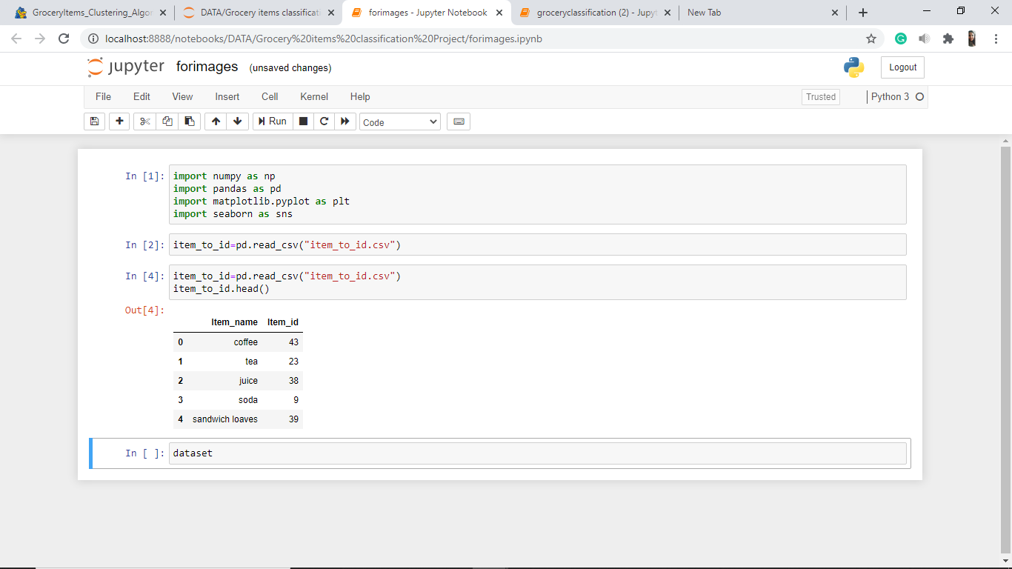

Shape:

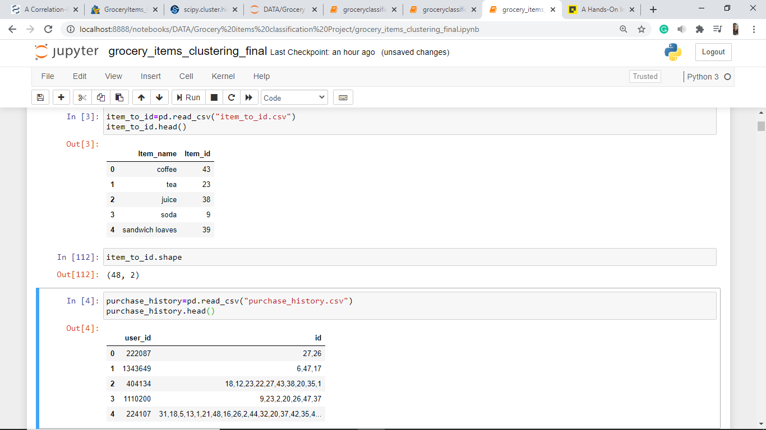

***purchase_history.csv*** file

First 5 rows of the dataset:

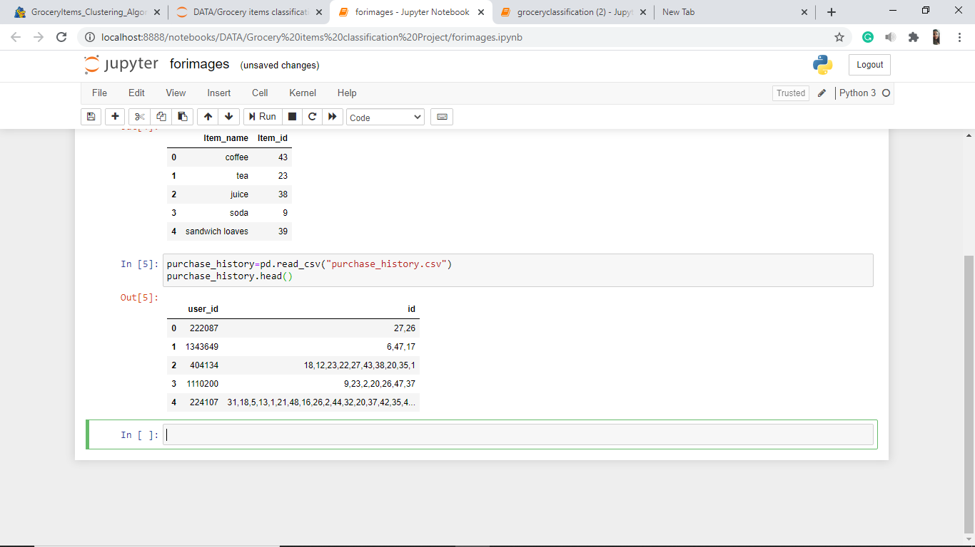

Shape:

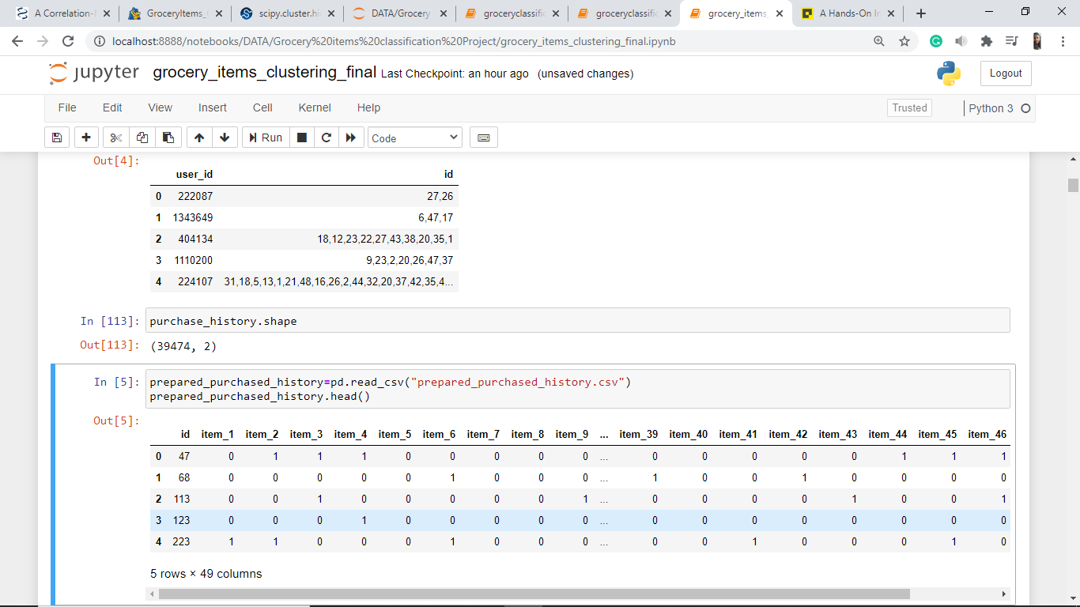

***prepared_purchased_history.csv***file

There are total of 49 columns in our dataset the first one corresponds to the customer id and the rest representing the 48 grocery items available.

First 5 rows of the dataset:

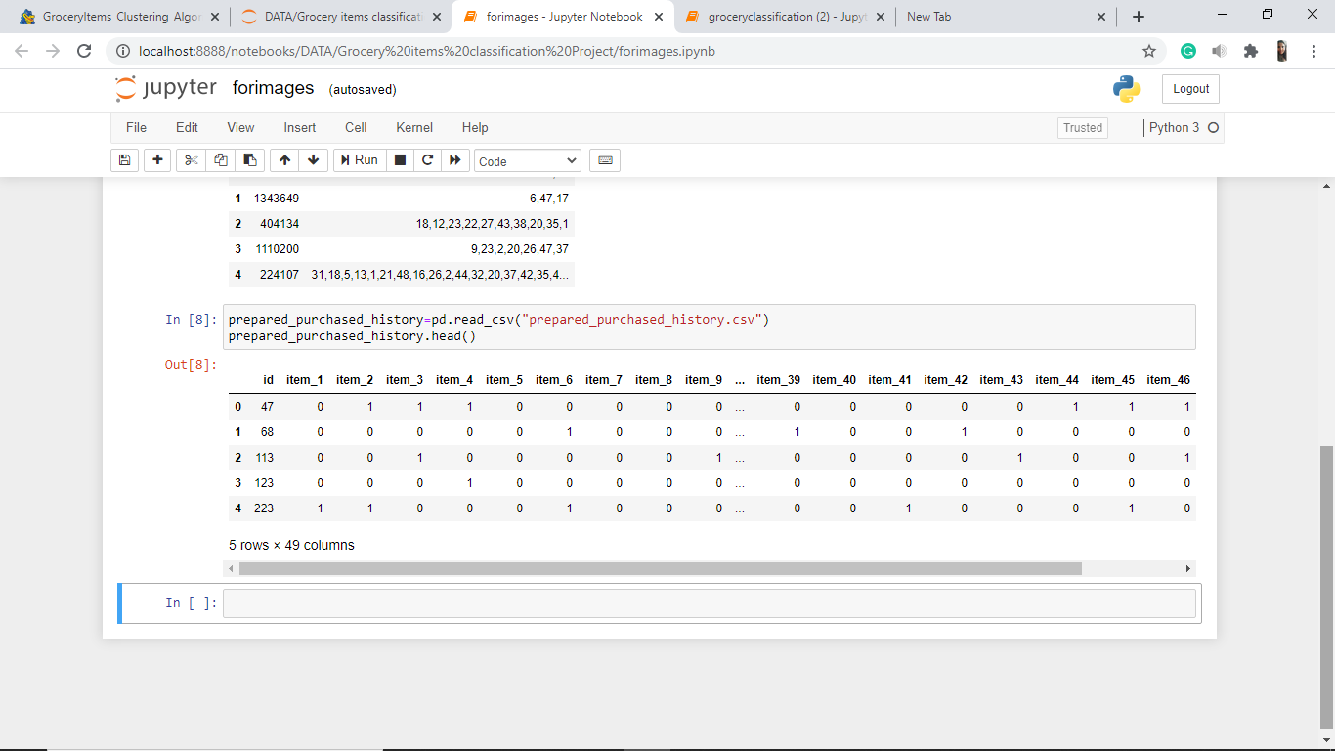

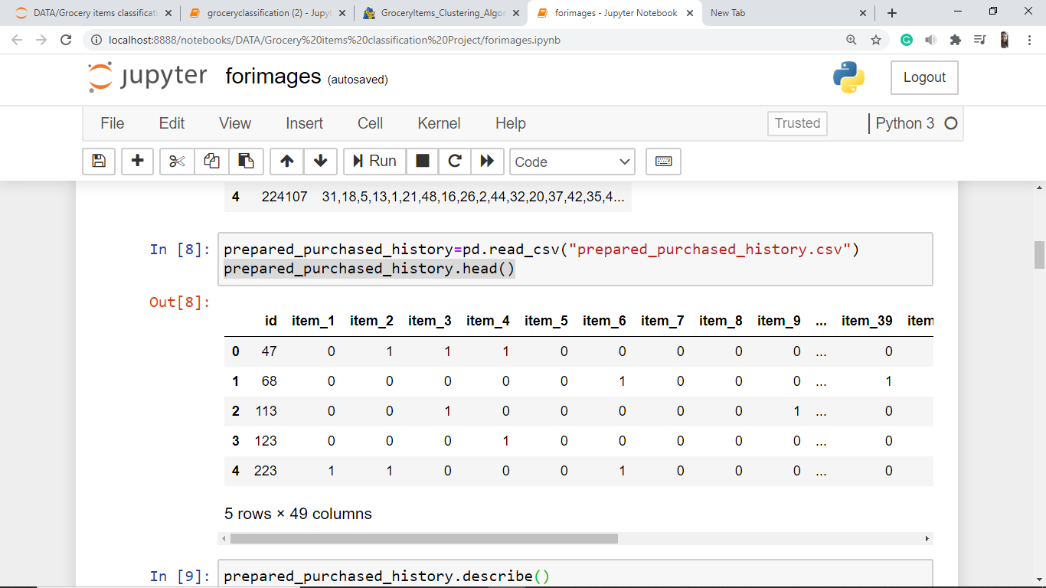

(Continued…)

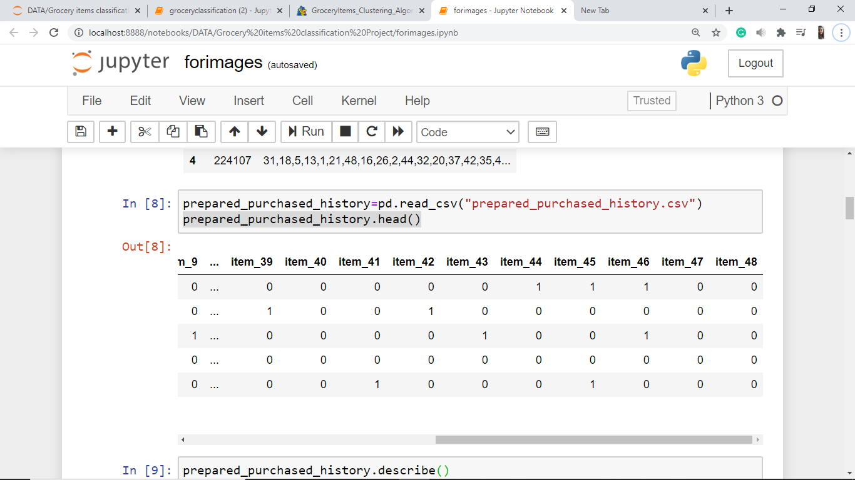

Shape:

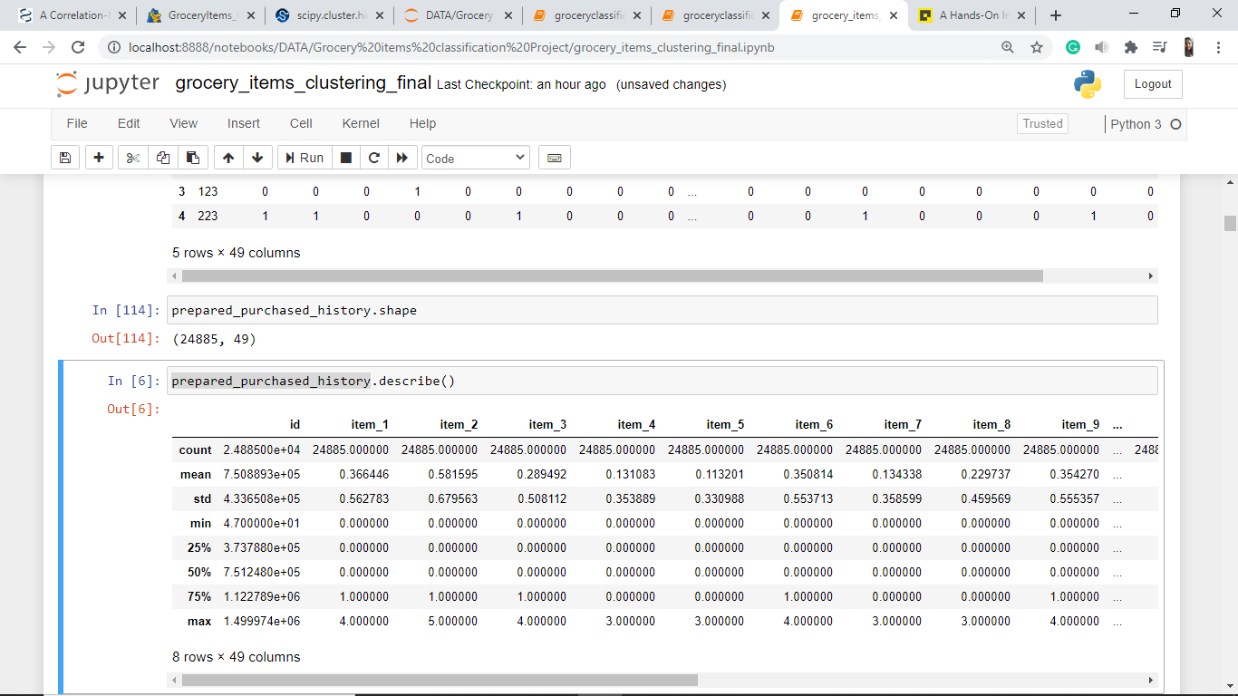

**DATA ANALYSIS**

We have checked for categorical feature and found that there are none. So we have concluded that there are only numerical features in the *prepared_purchased_history* file.

Now we can begin working on our problem statements.

1. **Detect the customer who bought the most items overall in their lifetime**

**Importing Libraries**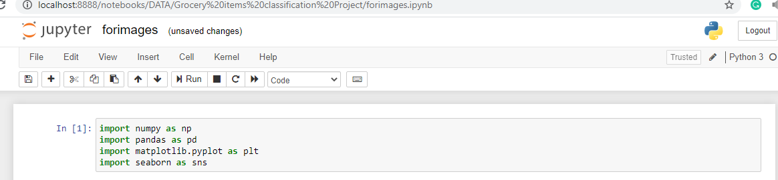

**Importing Dataset files**

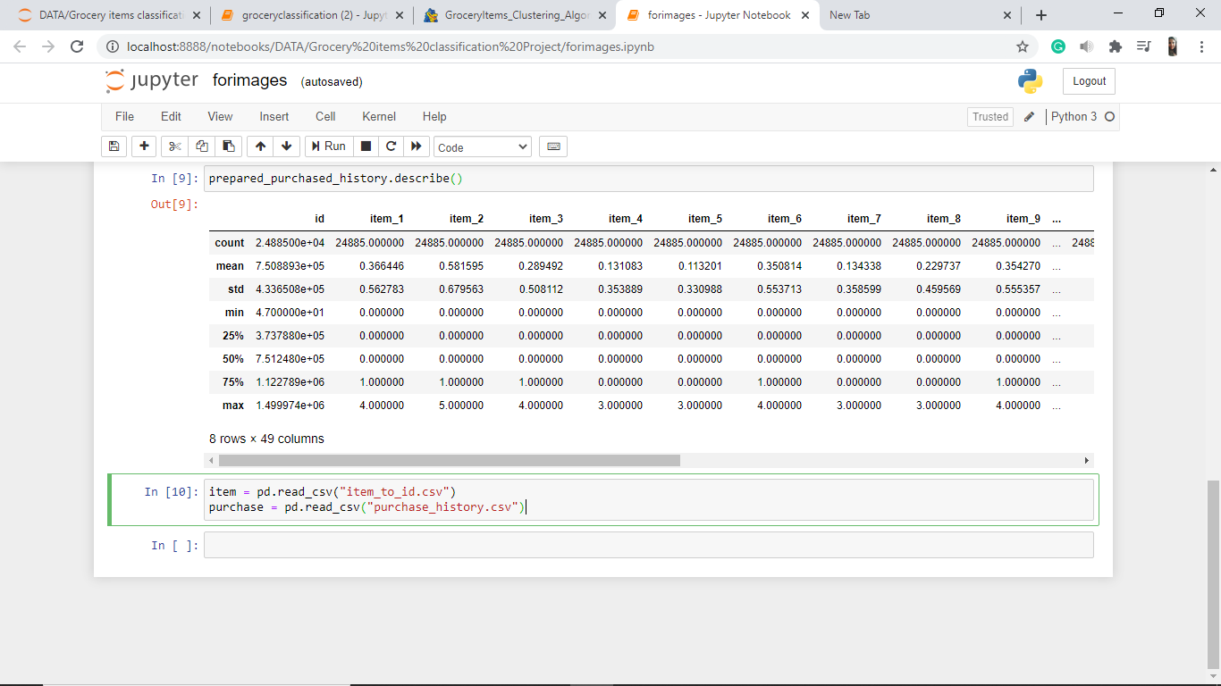

Creating Item Dictionary

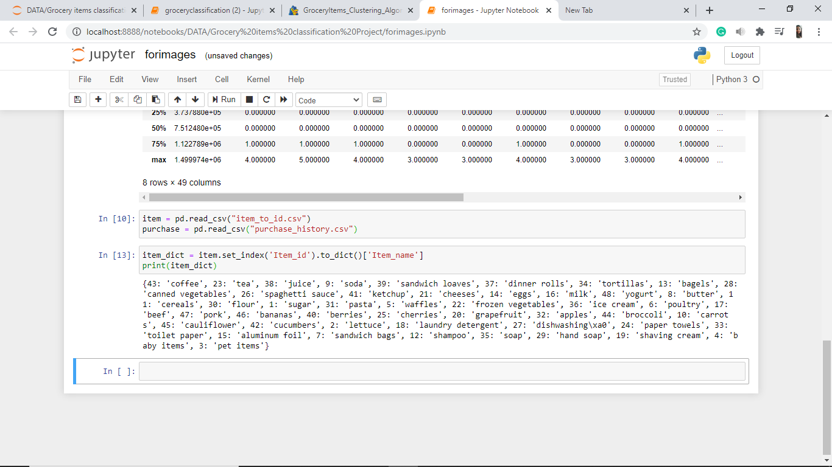

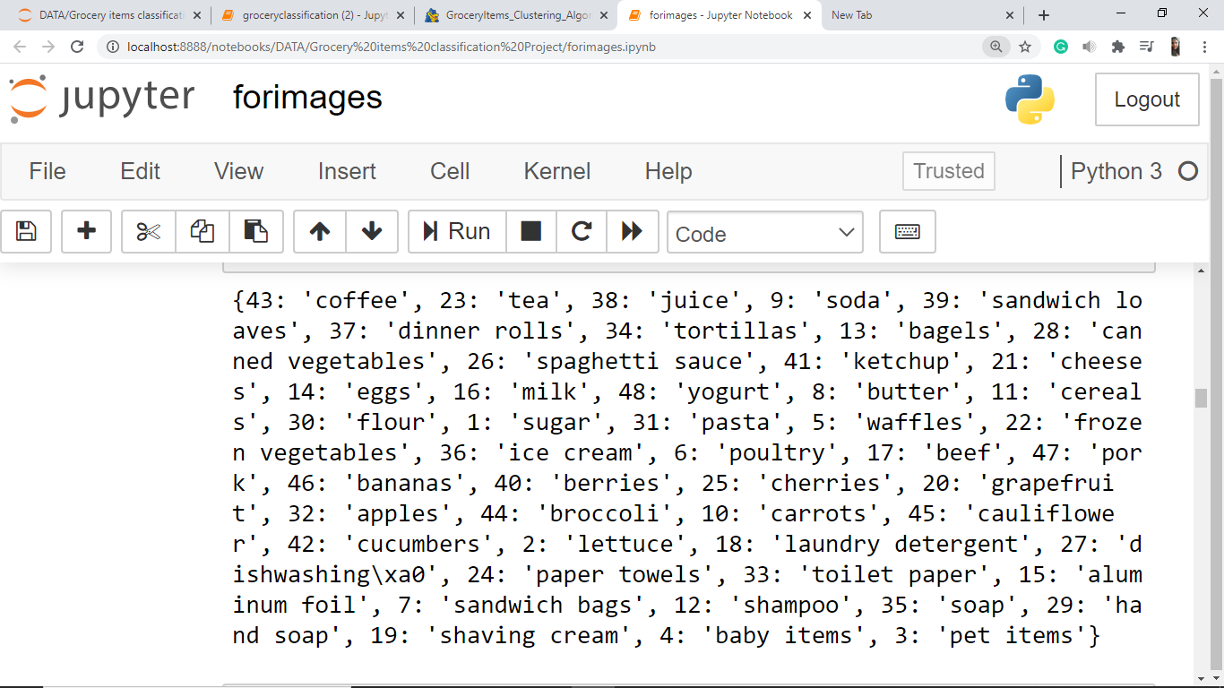

Creating new column in *purchase* by name *items_bought*

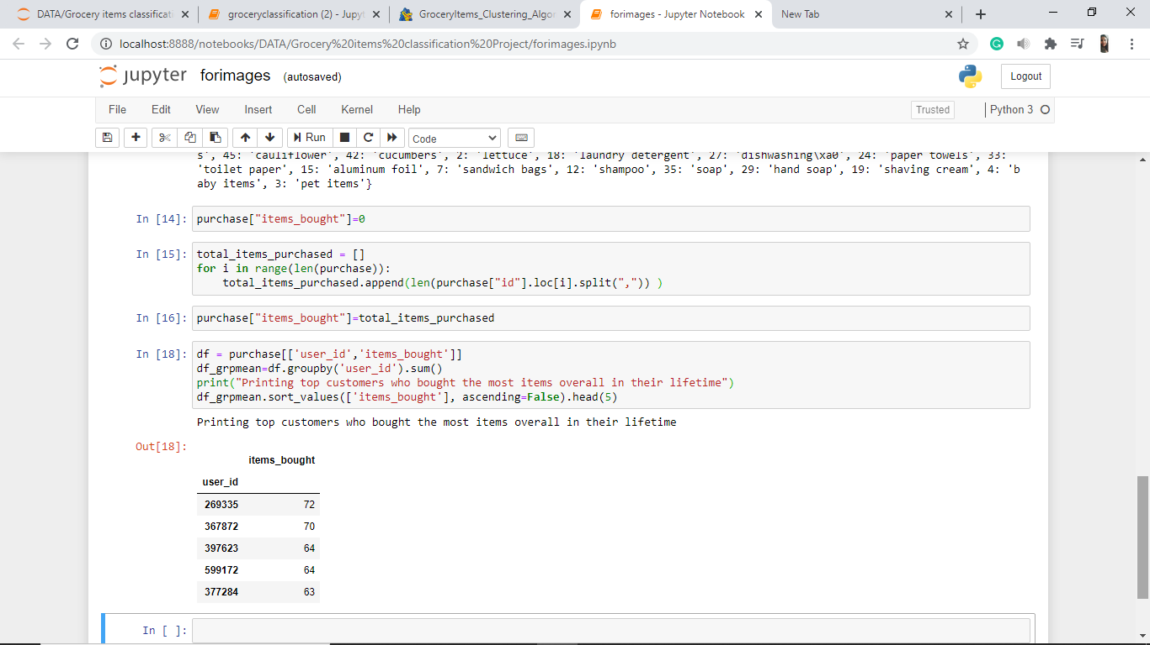

Counting the number of items in *id* column



Assigning the count to corresponding *items_bought* column value



Arranging user_ids in ascending order of item bought

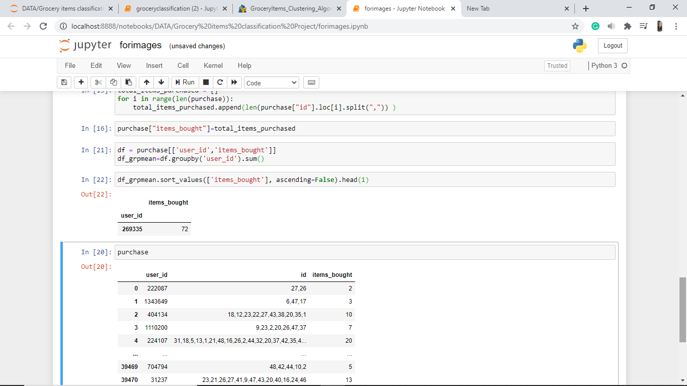

**Printing the top customer who bought the most items overall in their lifetime**



**The user with user_id = 269335 has bought 72 items in their lifetime.**

1. **For each item, find the customer who bought that product the most**

Creating *item_arr* of purchase items (shopping-cart) per transaction for 39474 transactions

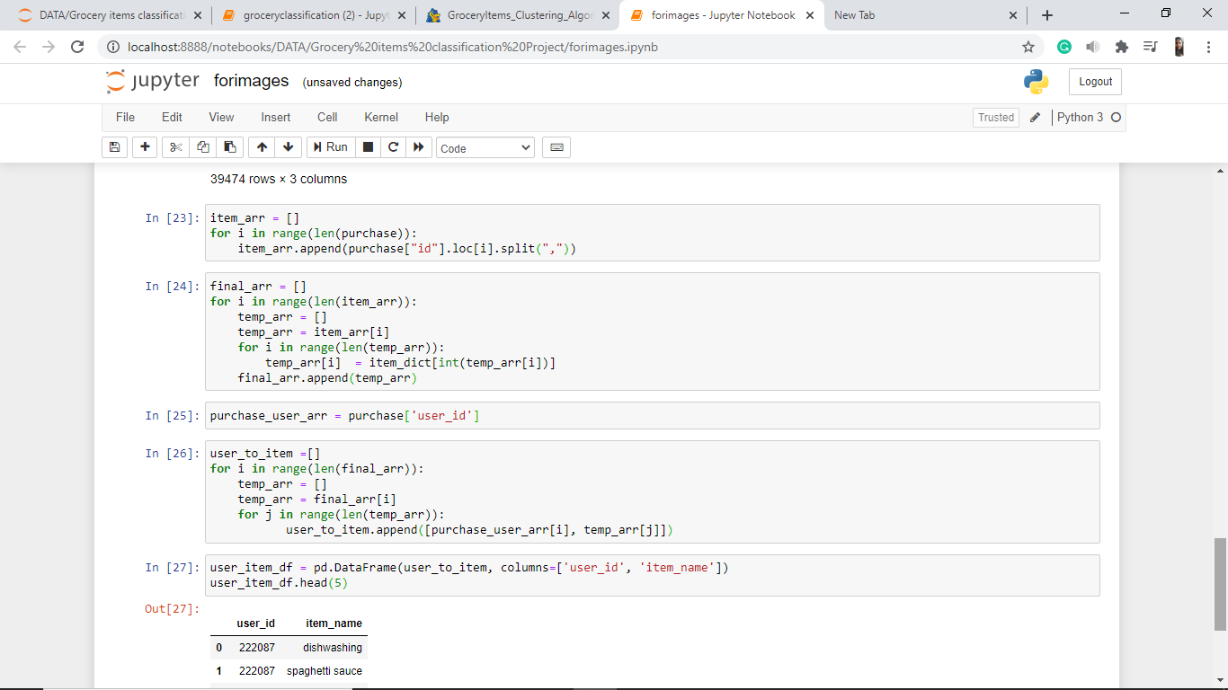

Mapping shopping-cart *item_ids* to *item_name*



Creating array with *user_id* values



Mapping *customer_id* with purchased grocery items



Creating *user_id* to *purchased item* DataFrame



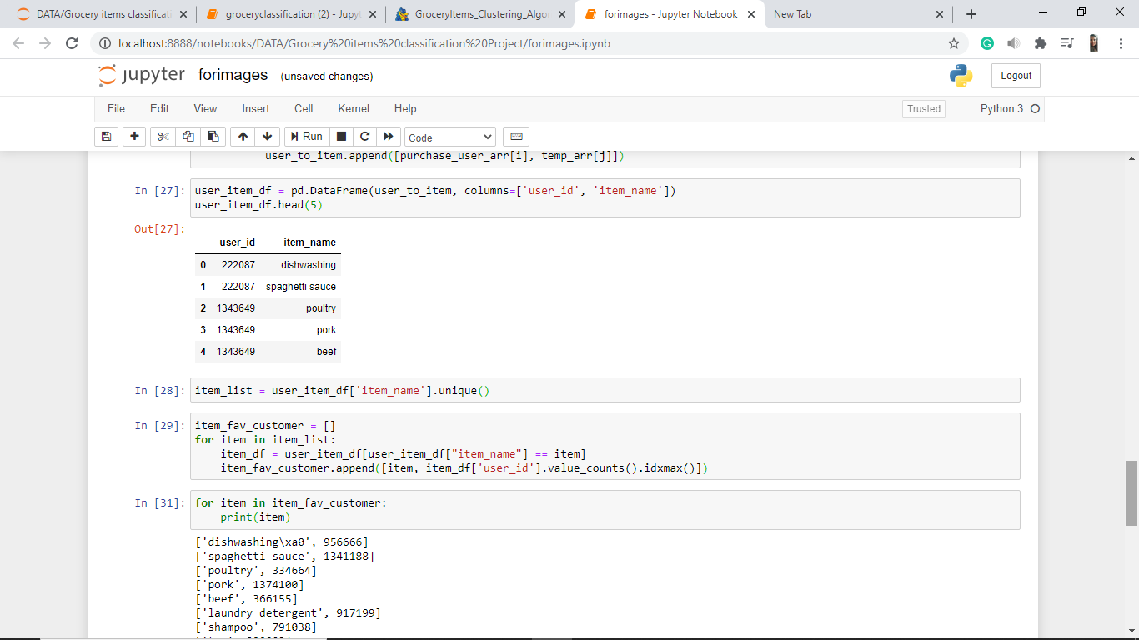

Identifying unique items and counting number of times it was purchased



We now create a DataFrame ‘*df*’ to store the *item name* and the *customer id* of the customer who has bought that item the most.

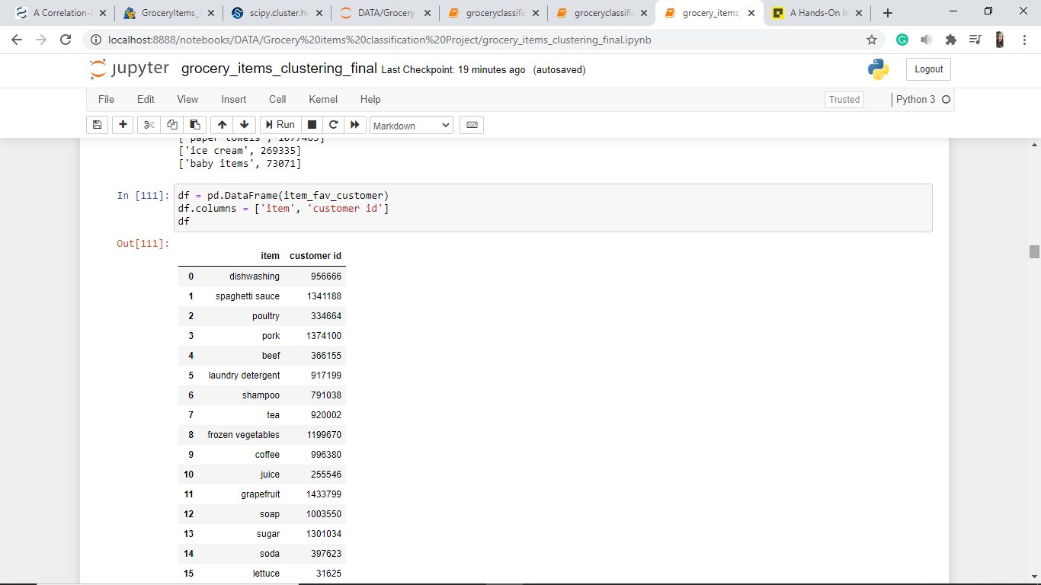

***df*** :

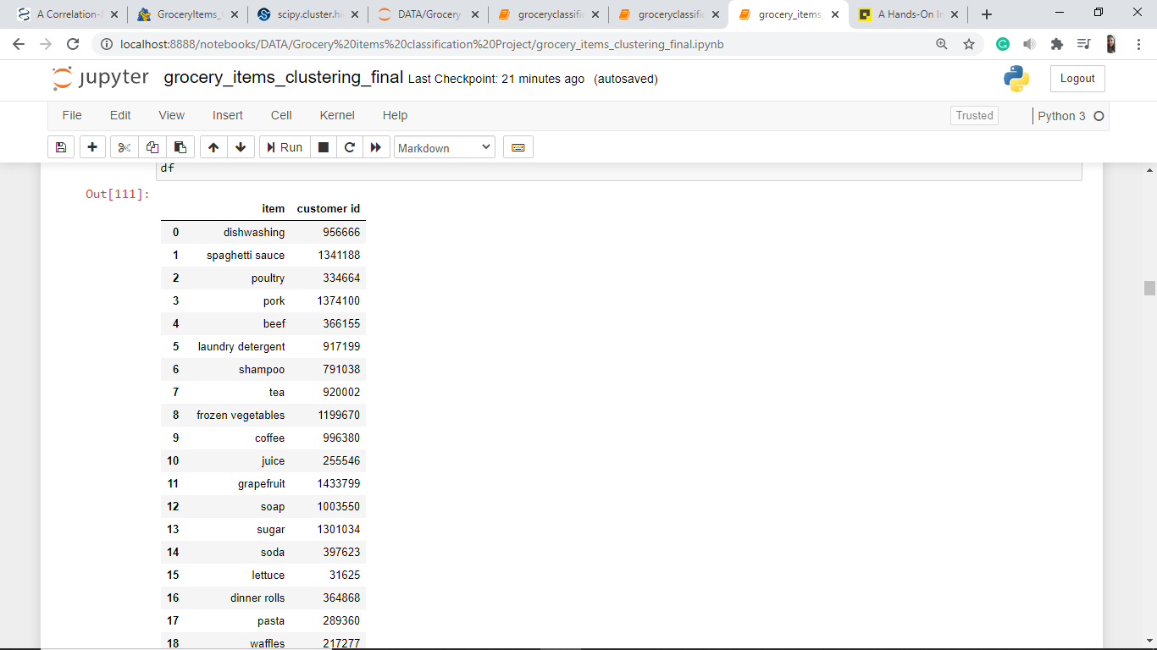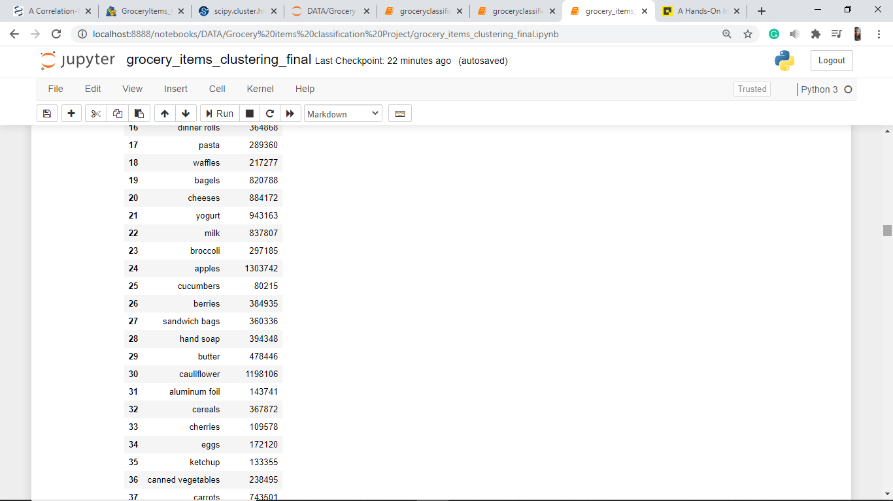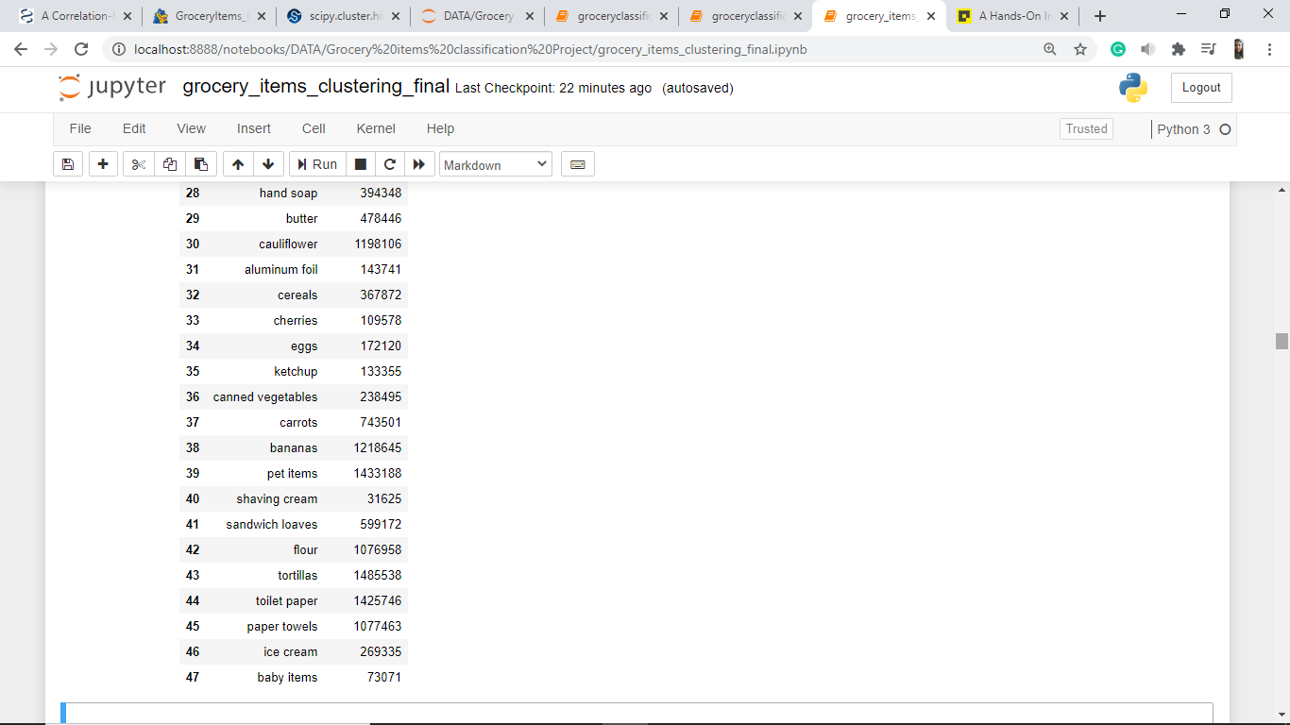

**DATA PREPARATION**

Algorithms require features with some specific characteristic to work properly. Here, the need for **Feature Engineering** arises. Feature engineering efforts mainly have two goals:

* Preparing the proper input dataset, compatible with the machine learning algorithm requirements.
* Improving the performance of machine learning models.

In our dataset *prepared_purchased_history.csv* file

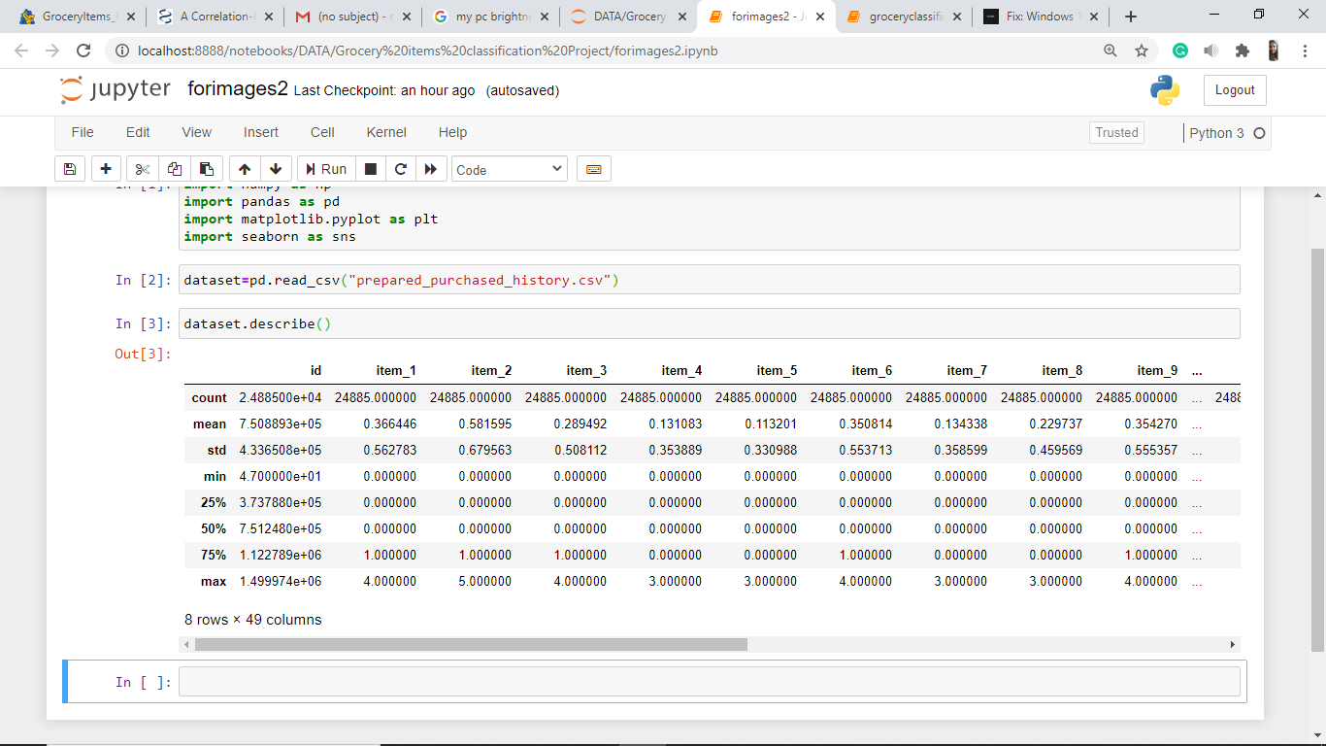



(Continued…)

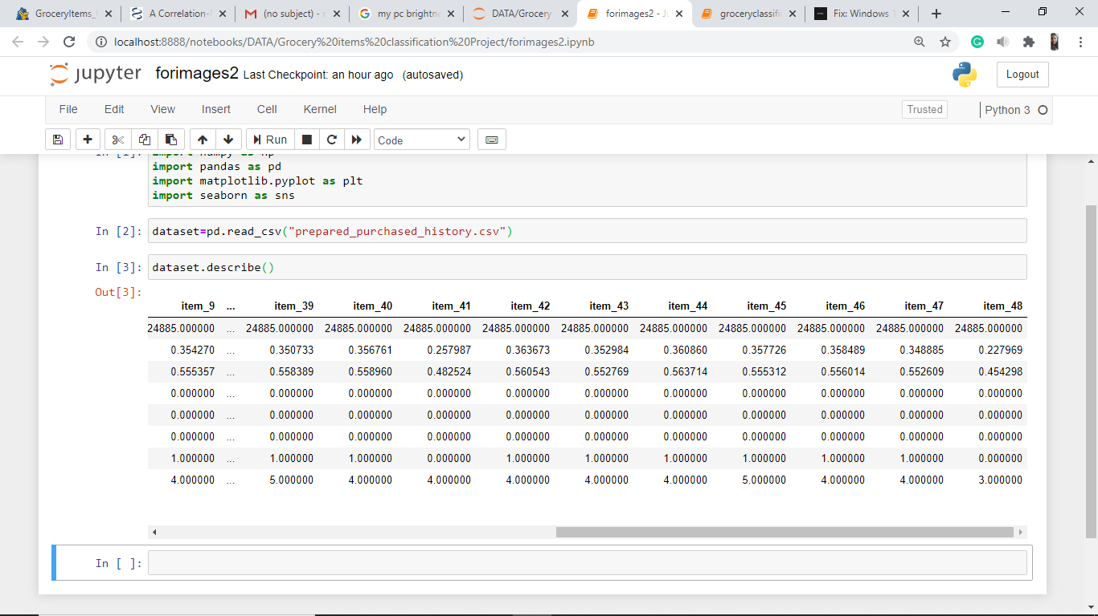

We have the first column representing the customer *id*. For forming clusters of the grocery items, we do not need the *id* column and hence this column needs to be removed.

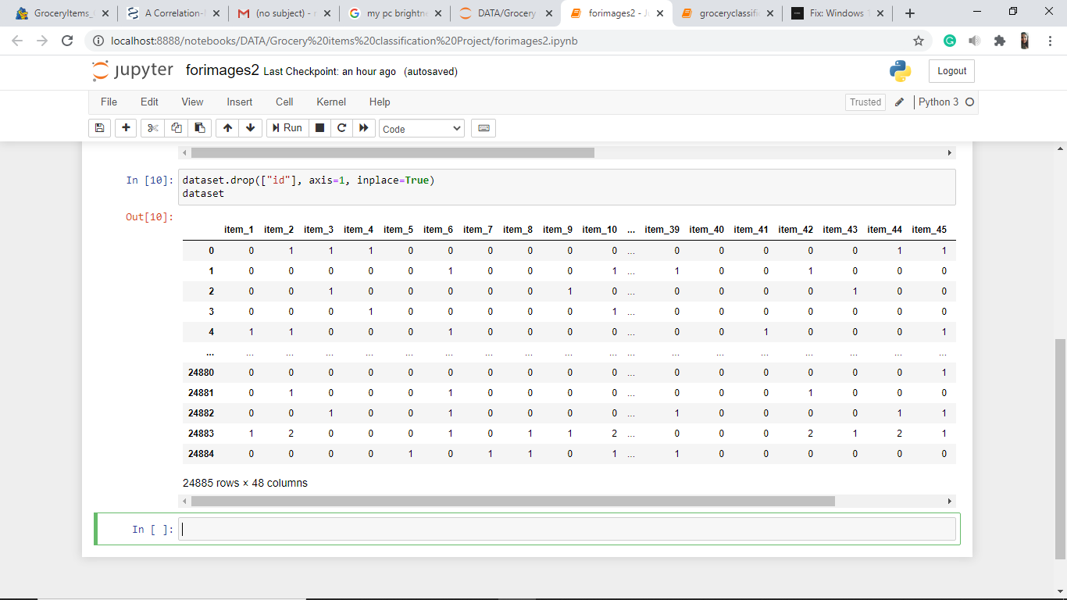

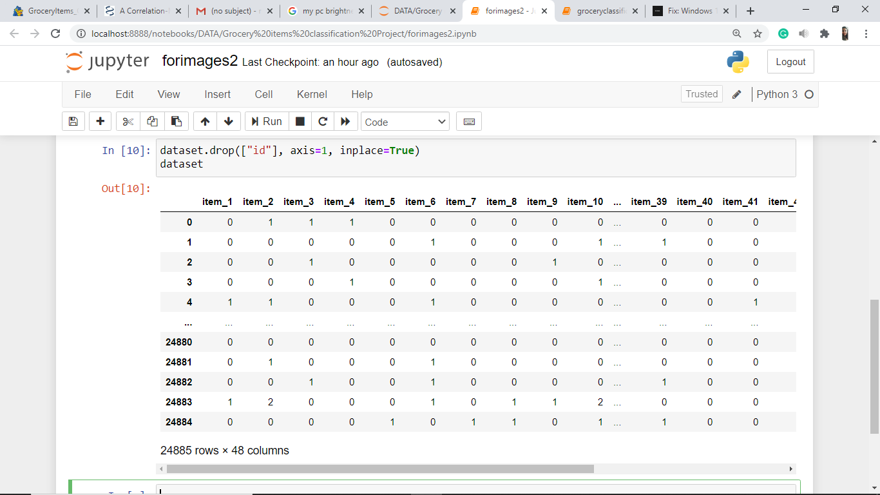

(Continued…)

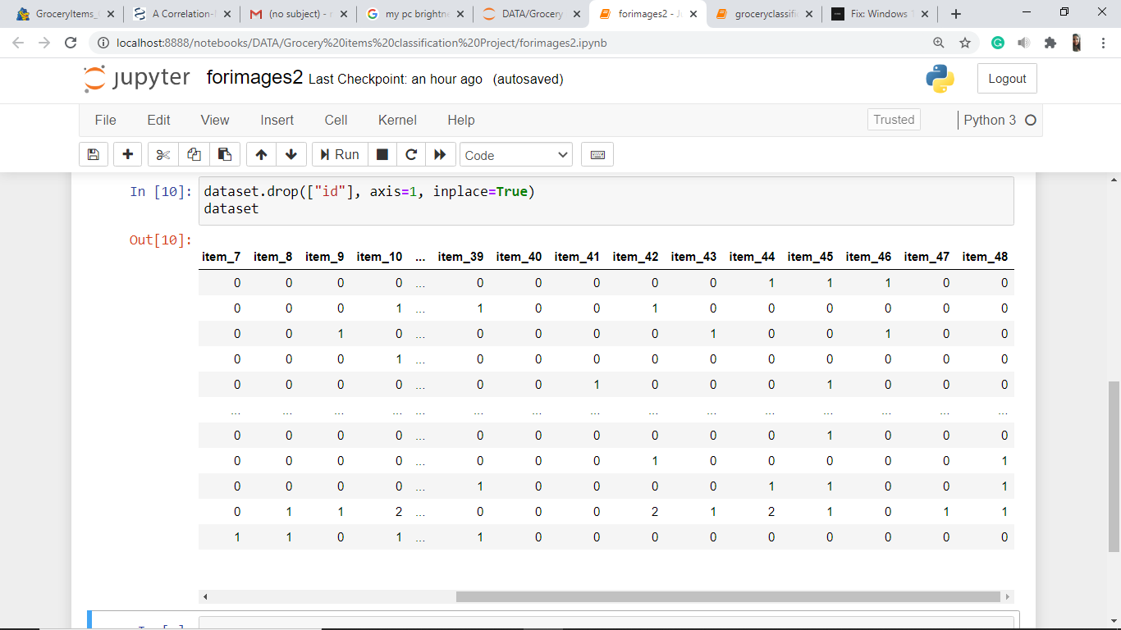

According to the problem statement, we need whether an item was bought by the customer or not. We do not need the quantity of the items bought. Hence we need a table representing value ‘1’ for item bought and ‘0’ for not bought.

Using the *user_item_df* DataFrame created previously,

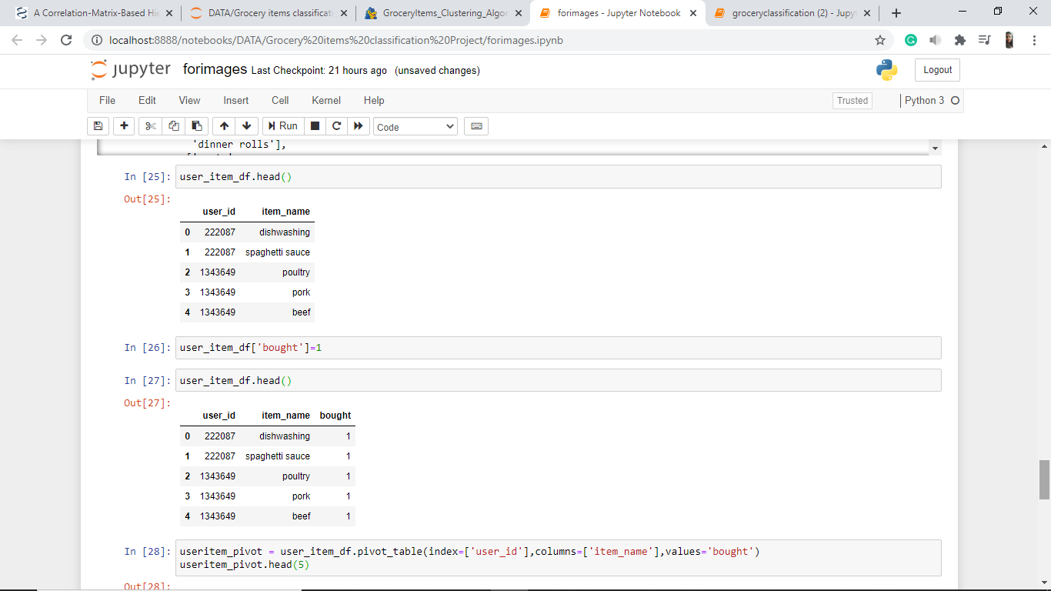



Adding a new column *bought* to *user_item_df*,





Using the above DataFrame with *user_id* and *item_name*, we create a table *useritem_pivot* containing value ‘1’ for item purchased by that user and NaN for not purchased items.

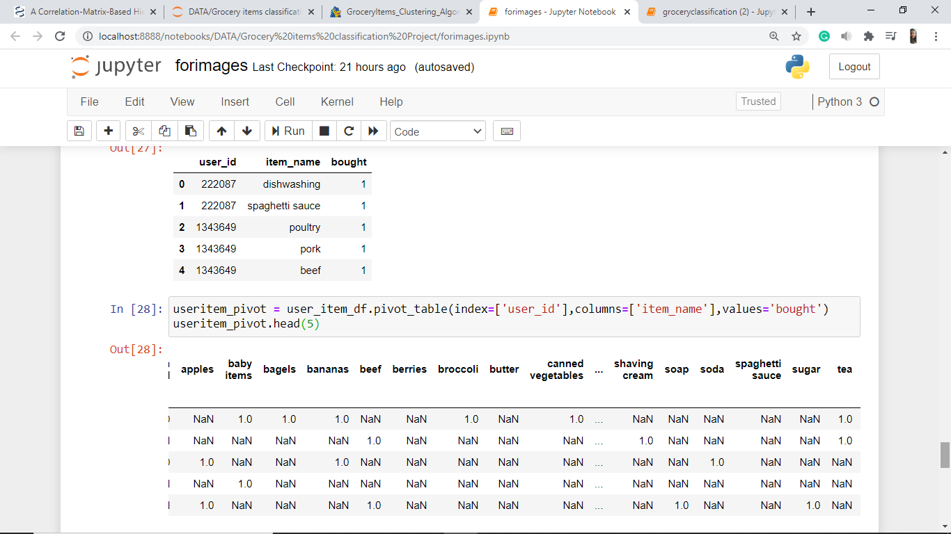

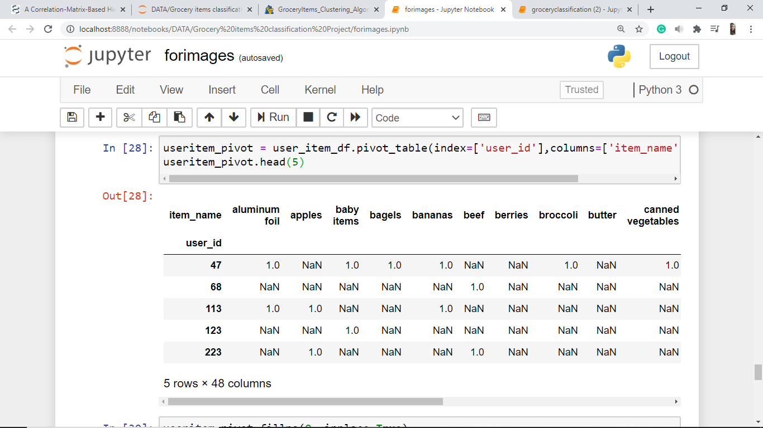

(Continued…)

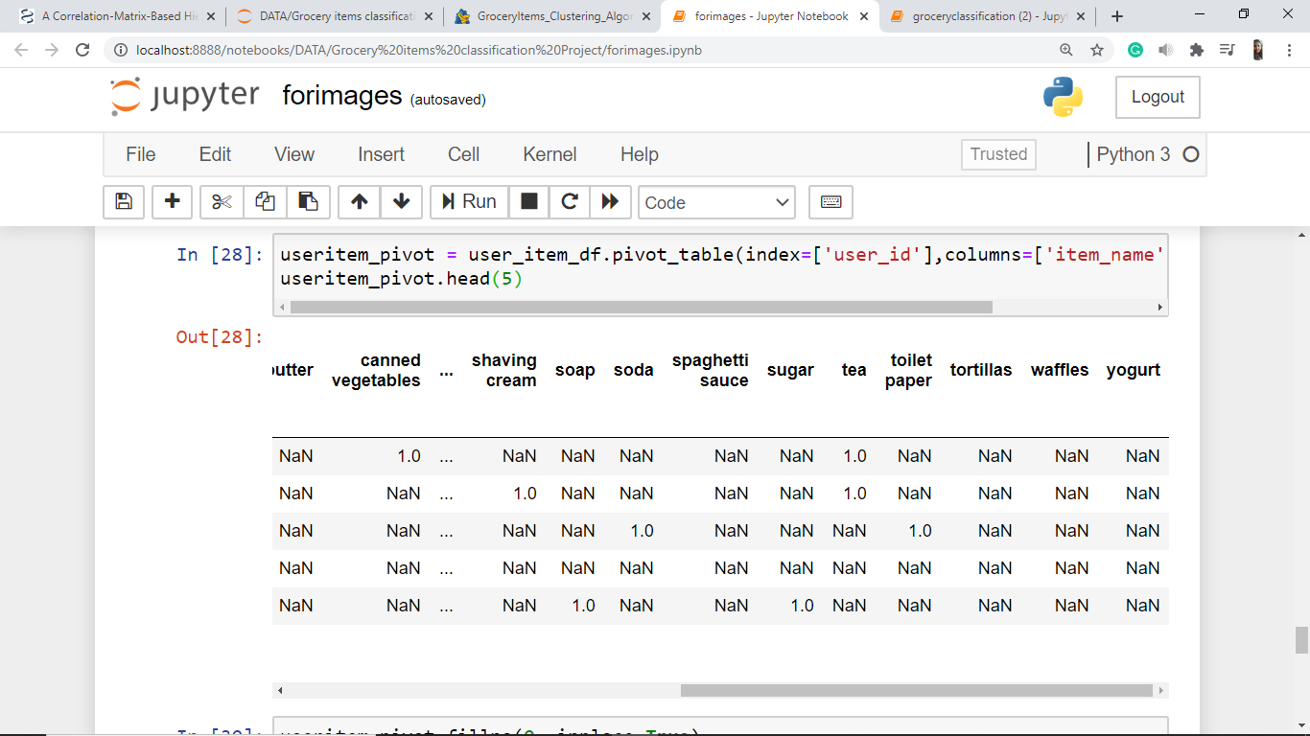

Filling all NaN valued cells with ‘0’,

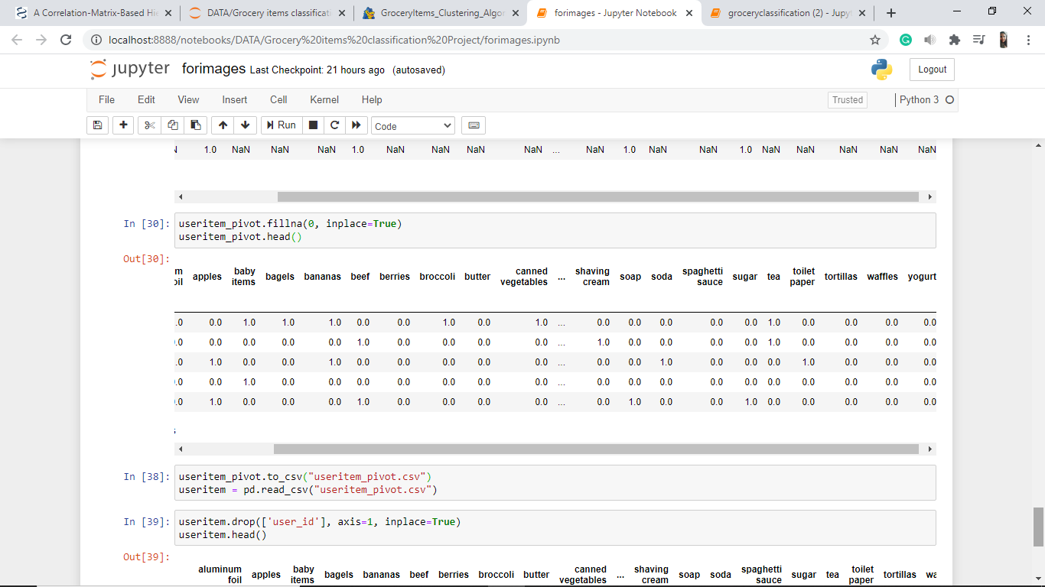

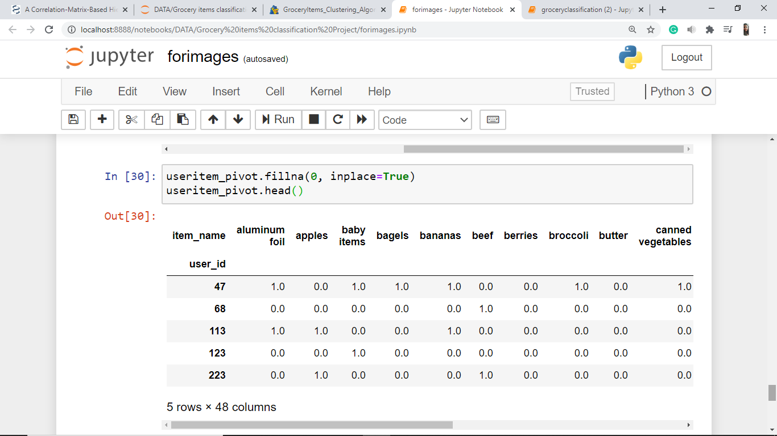

(Continued…)

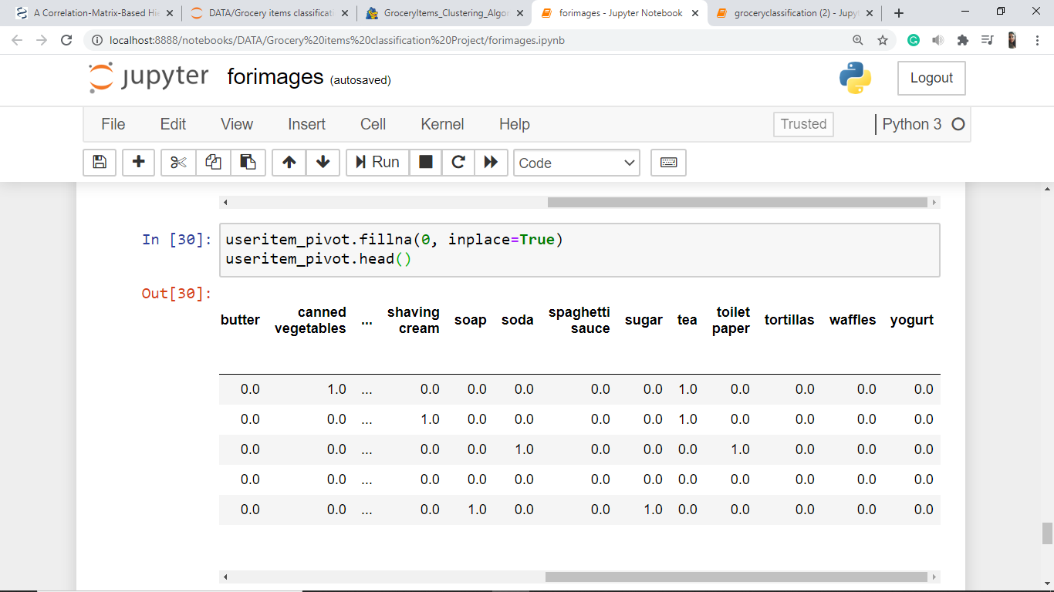

Saving the *useritem_pivot* table to csv file *useritem_pivot.csv*,

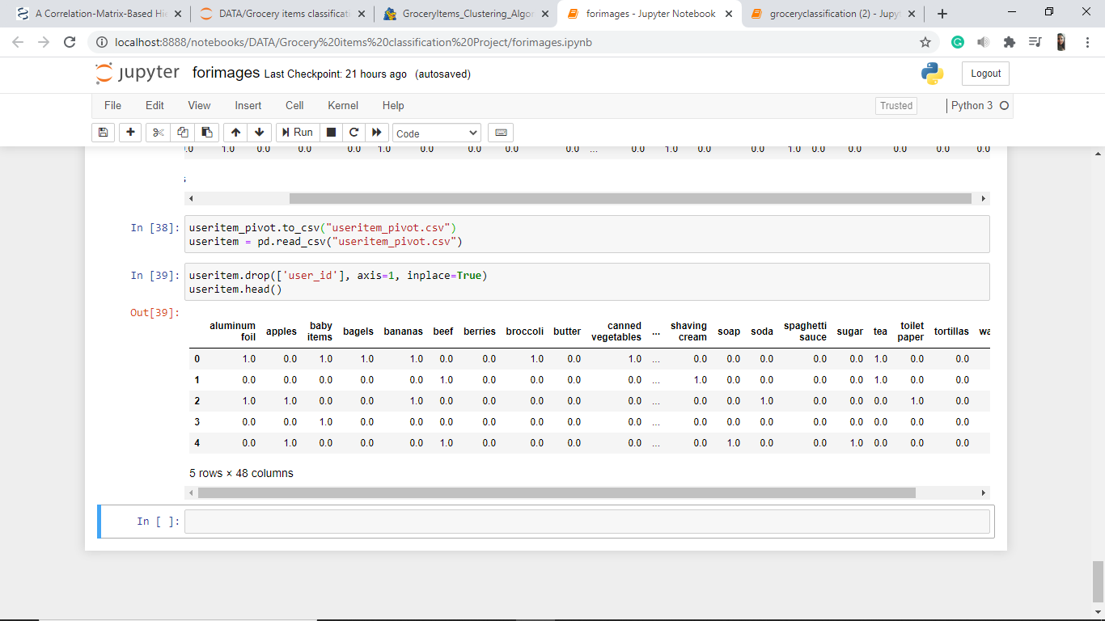

Dropping the *user_id* column,



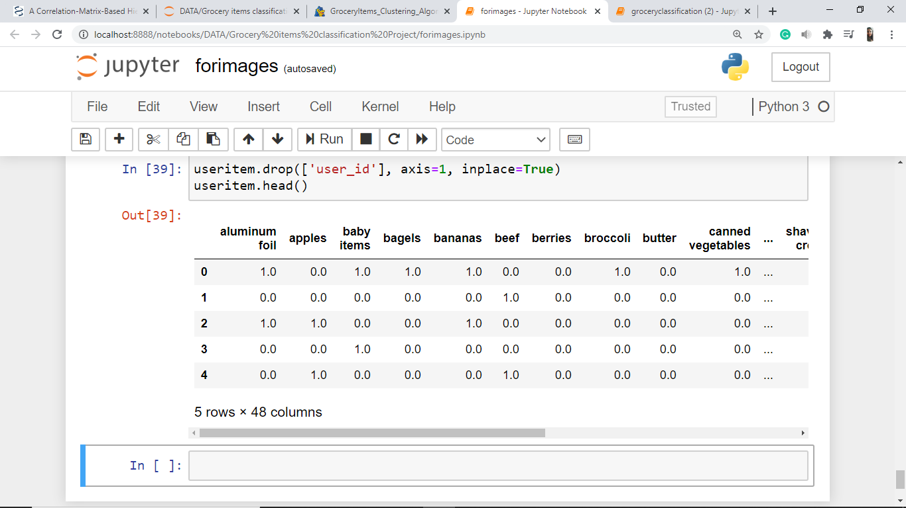

(Continued…)

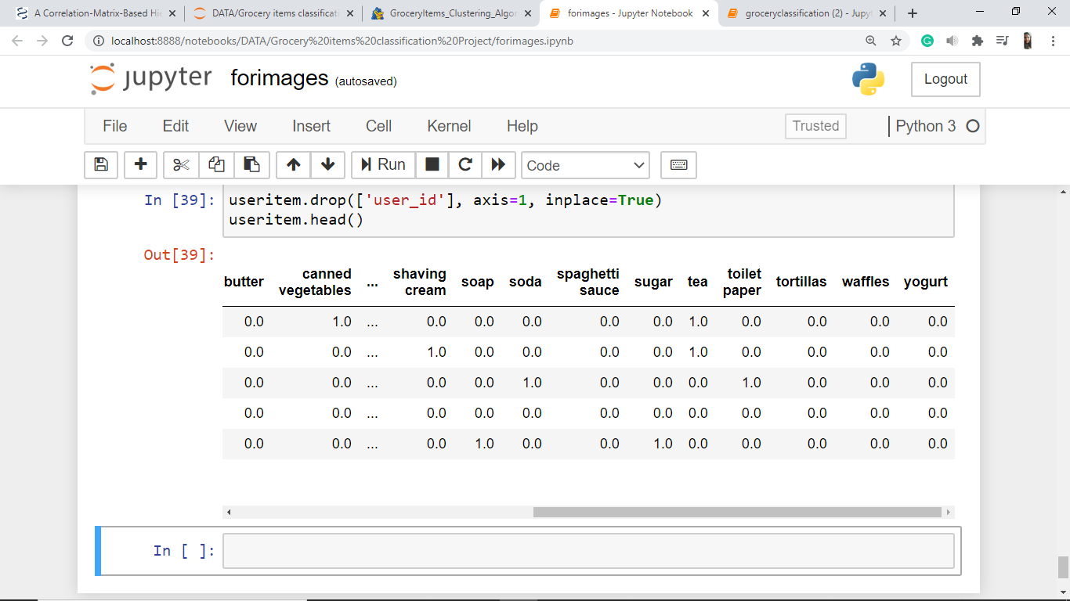

**CLUSTERING**

Now we can begin clustering our data.

Elbow Method is used to determine the optimal number of clusters possible for the data.

**Elbow Method:**

Importing KMeans library from sklearn.cluster

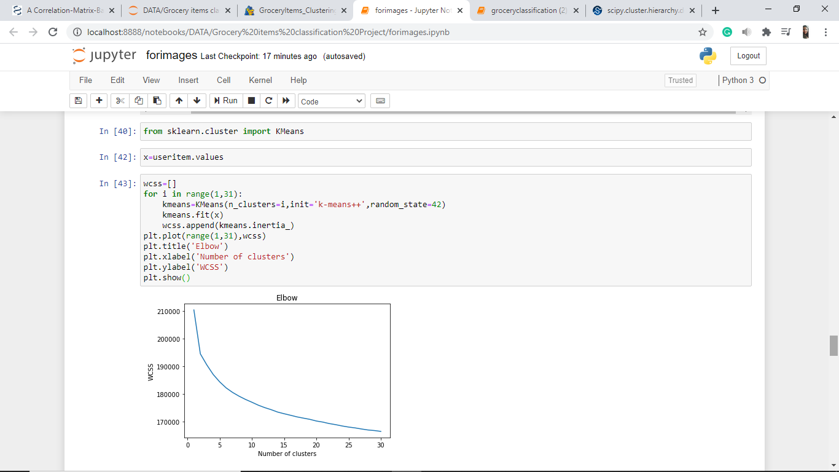

*x* is a numpy array made from *useritem* DataFrame



Plotting the elbow curve by varying cluster size vs. squared error

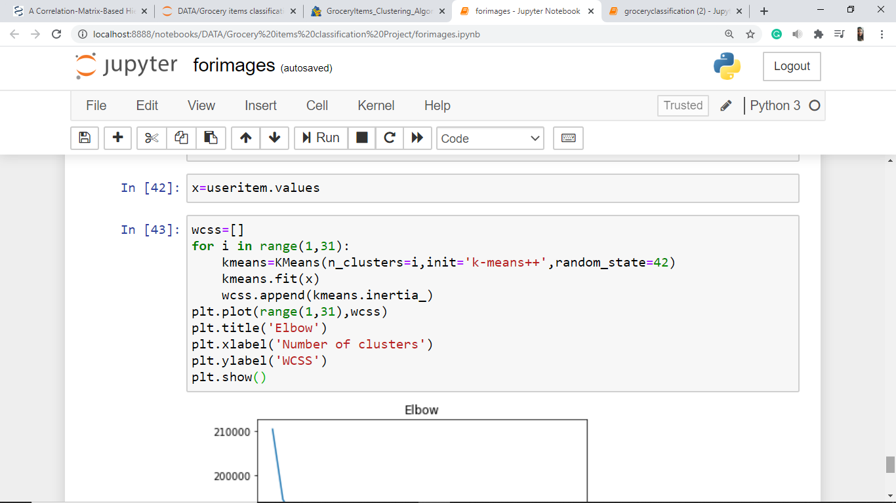

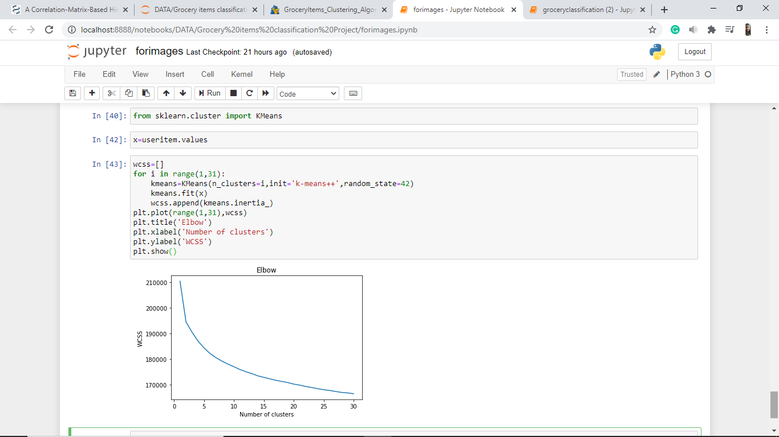

No sharp elbow detected.

Let us try another method of clustering, Hierarchical Clustering because:

* The hierarchical clustering algorithm determines the optimal number of clusters by plotting a dendrogram.
* We can visualize the categories of items and see which items fall in the same cluster effectively in hierarchical clustering.

**Hierarchical Clustering:**

**Preparation of Data for Hierarchical Clustering:**

In order to perform hierarchical clustering, the data should be in the form of a correlation matrix.

Creating *corr*, correlation matrix of shape (48 x 48) for *useritem* DataFrame

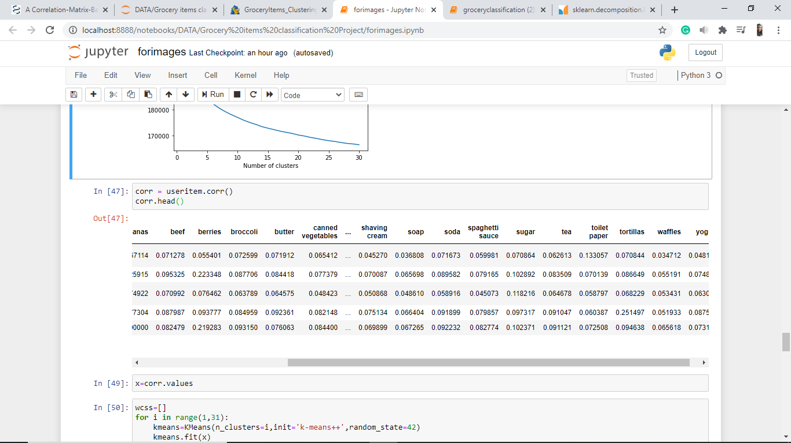

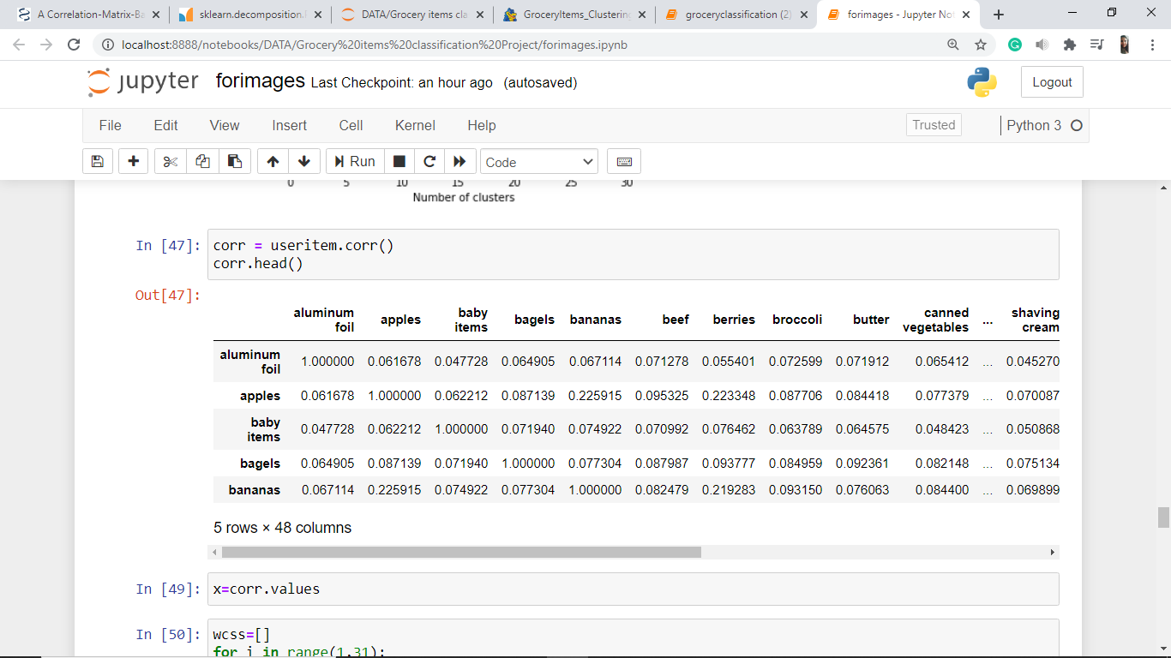

(Continued…)

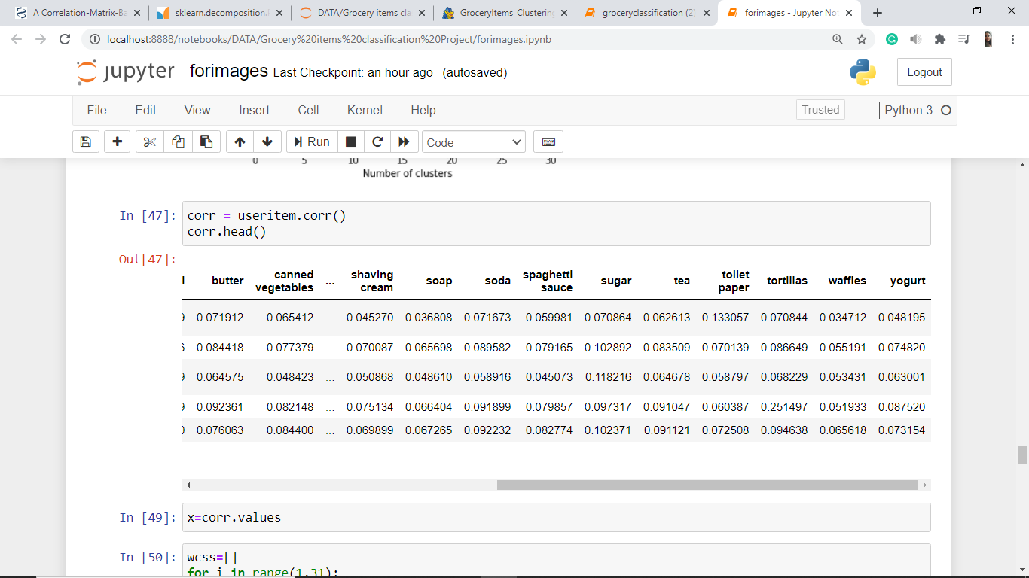

Now, we create a list containing strings representing the item name in order to use as labels for the leaf nodes in the dendrogram.

Using the *item_name* column from *user_item_df* DataFrame:

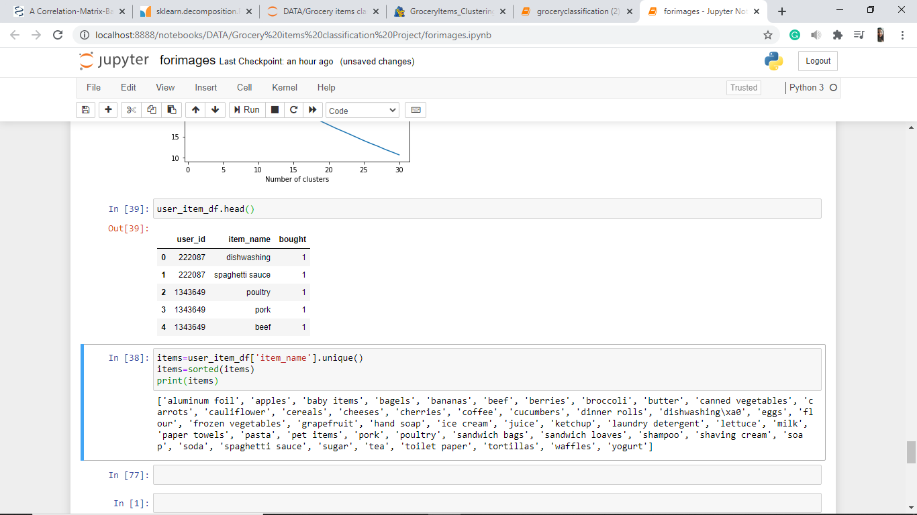

Extracting the unique values of *item_name* column and sorting, and storing them in a list named *items*

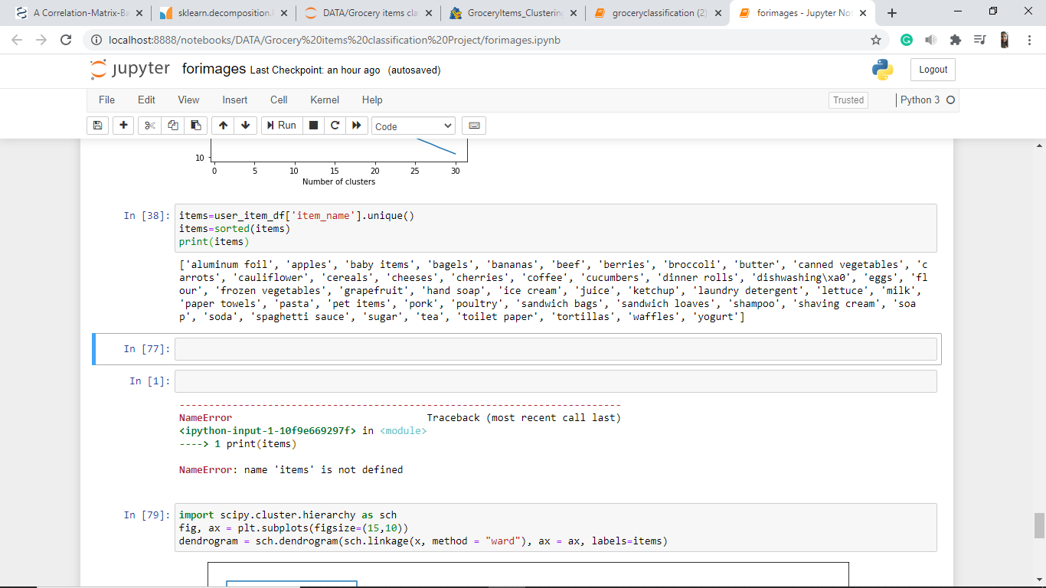

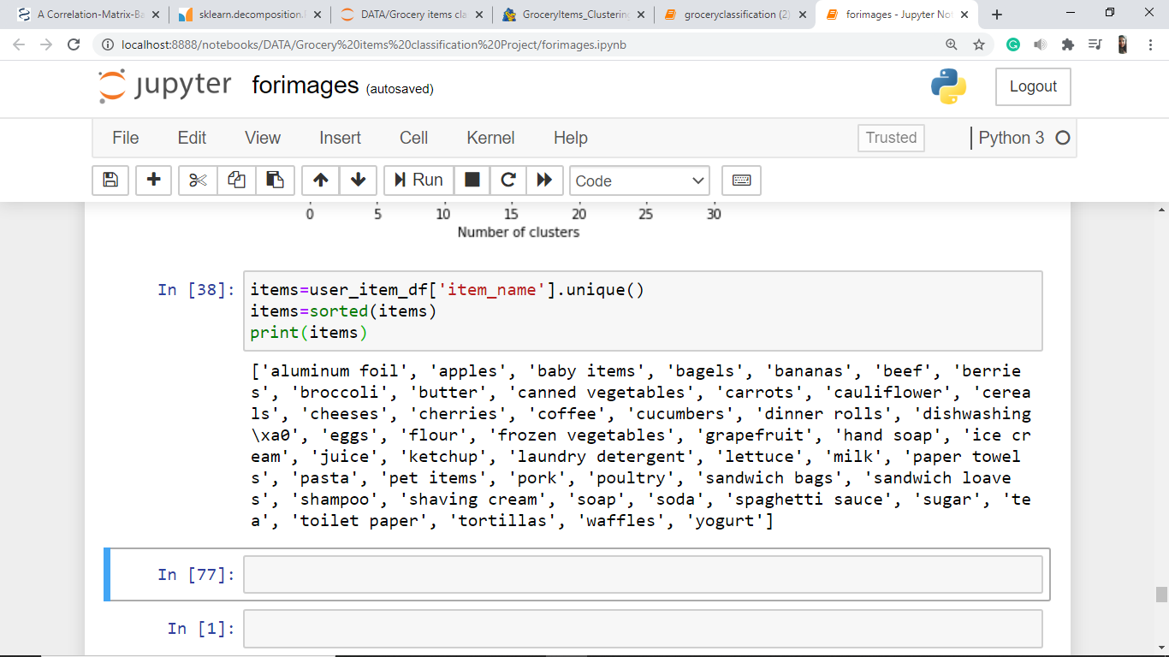

Converting *corr* of type DataFrame, to numpy array *x*:

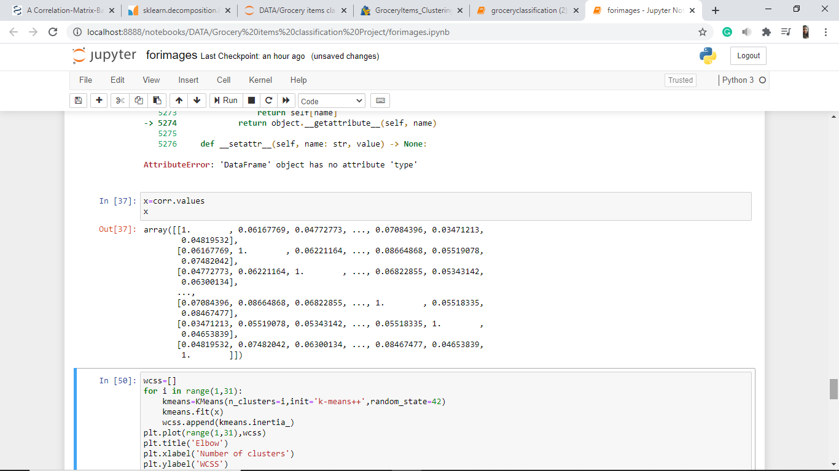

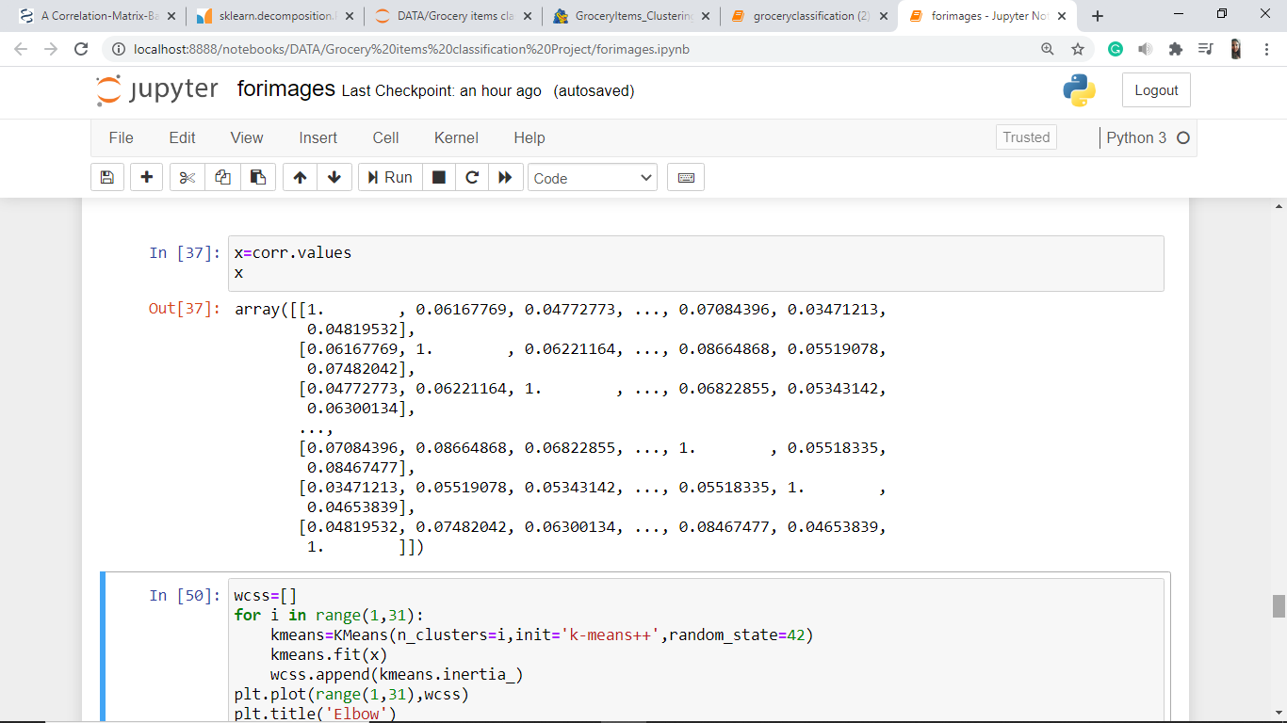

**Plotting the dendrogram:**

Importing scipy.cluster.hierarchy library:

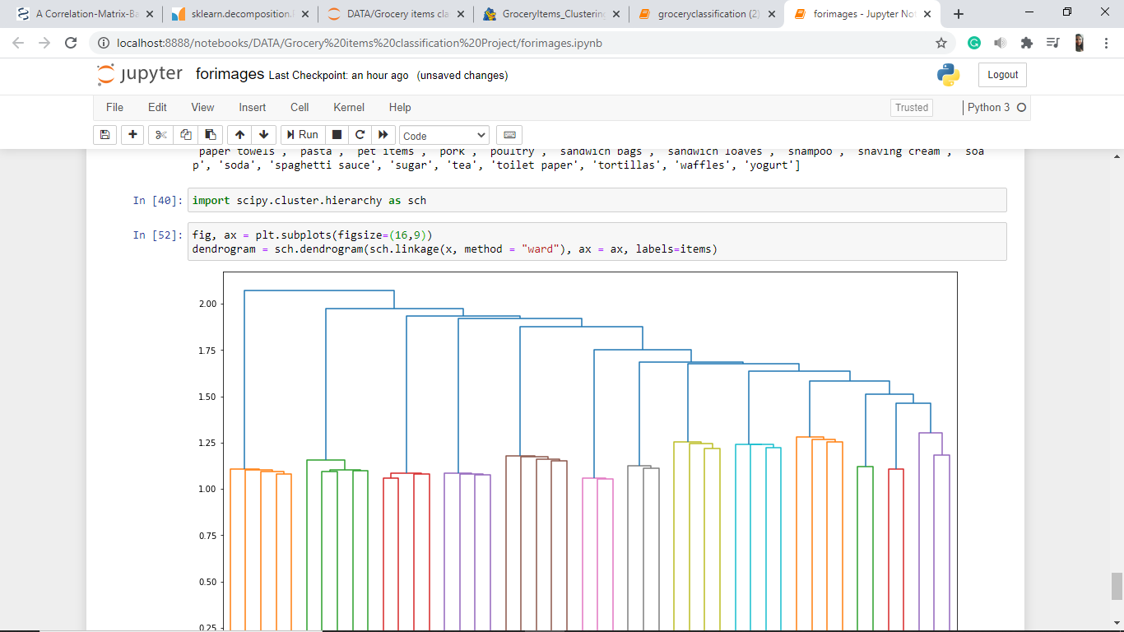

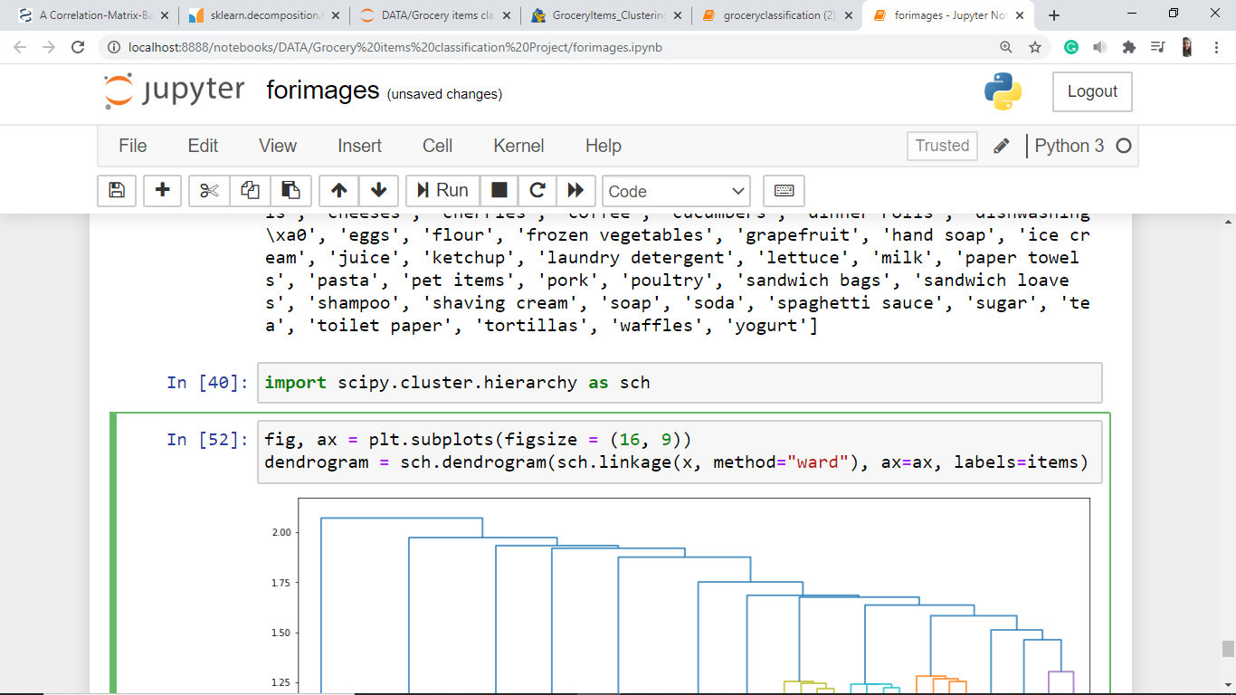

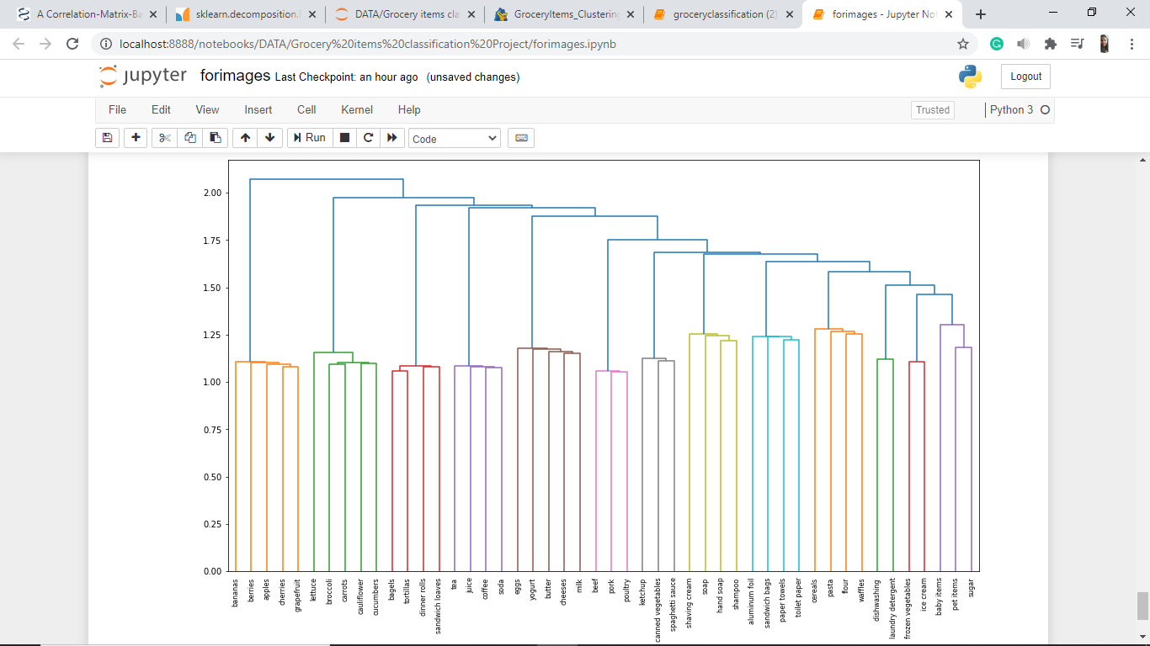

**Creating a list representing the cluster number for each item:**

Importing *fcluster* from *scipy.cluster.hierarchy*:

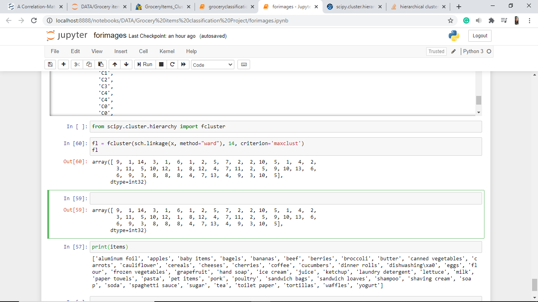

Passing the number of clusters to be 14, according to the dendrogram above

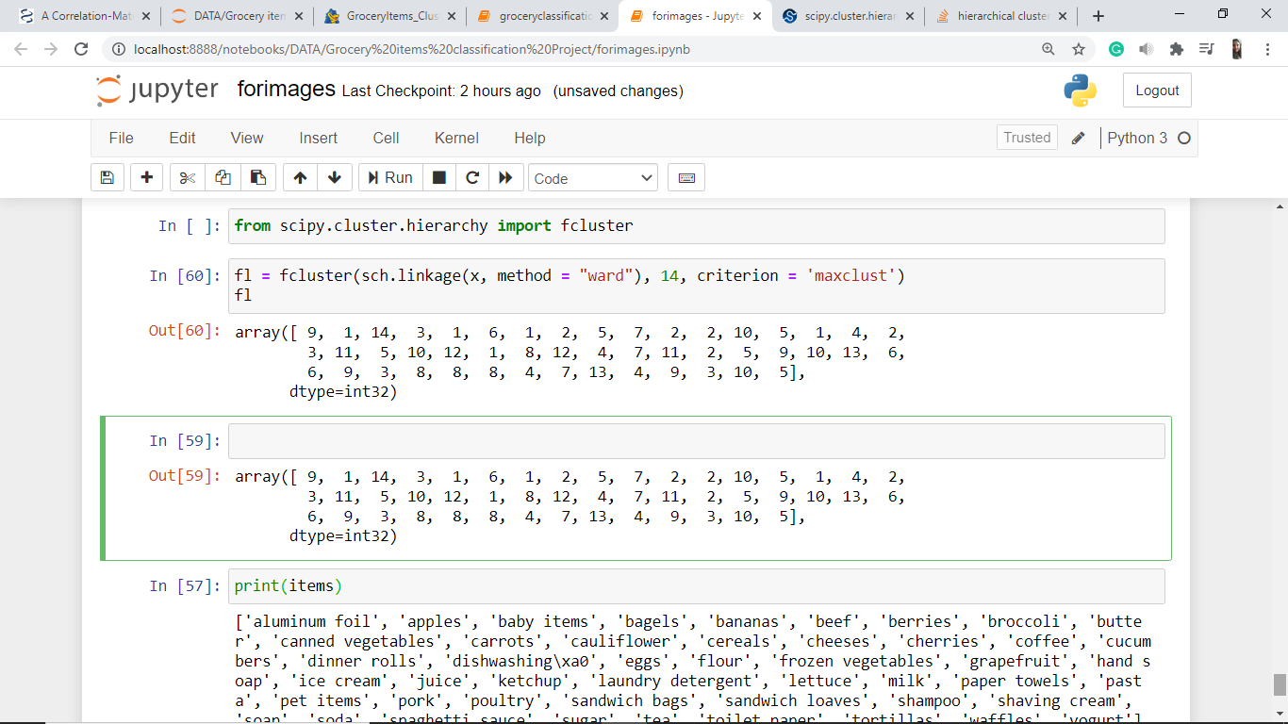

The array *fl* contains the cluster number corresponding to the item in the items list.

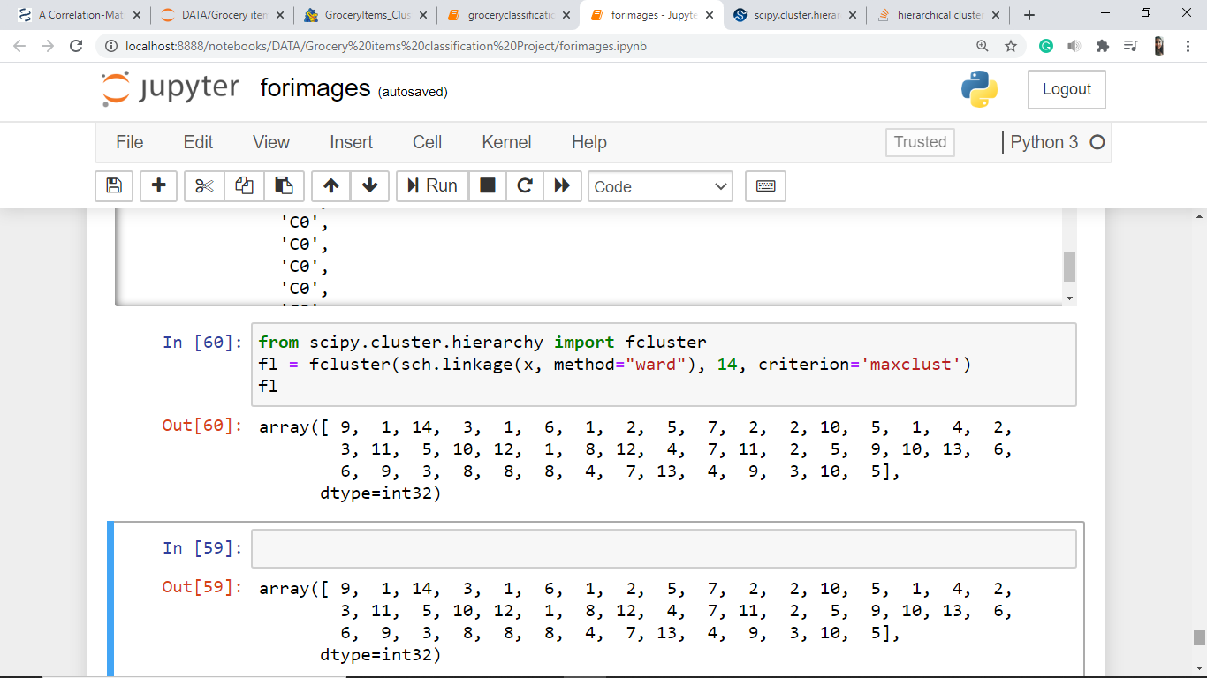

Here is the *items* list created previously:



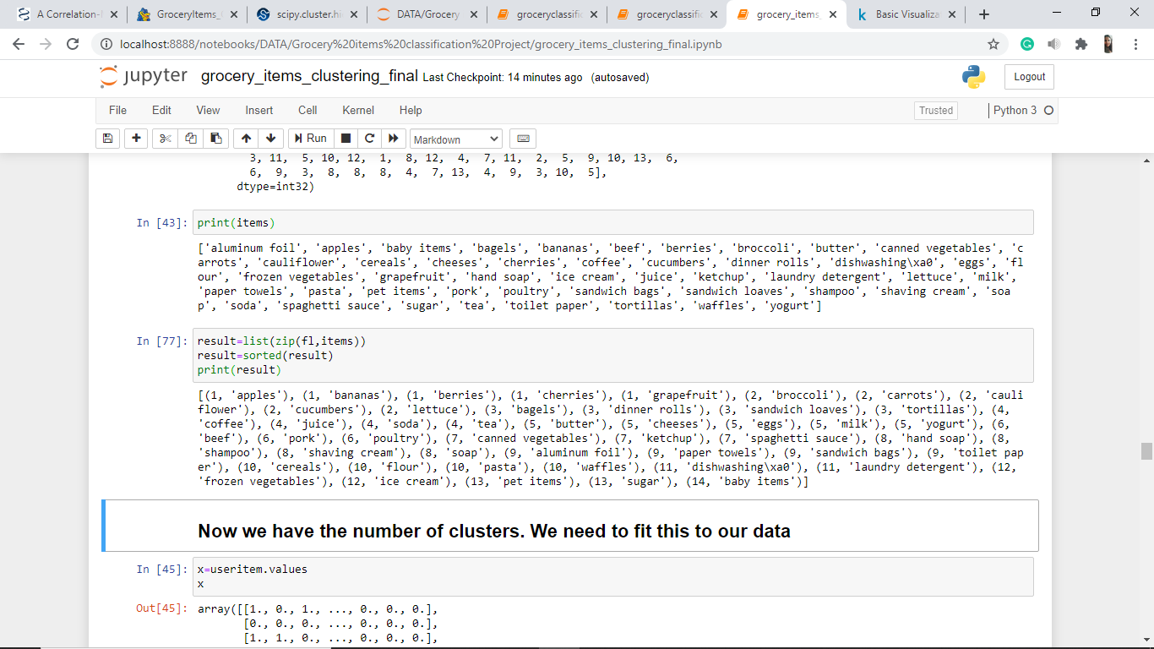

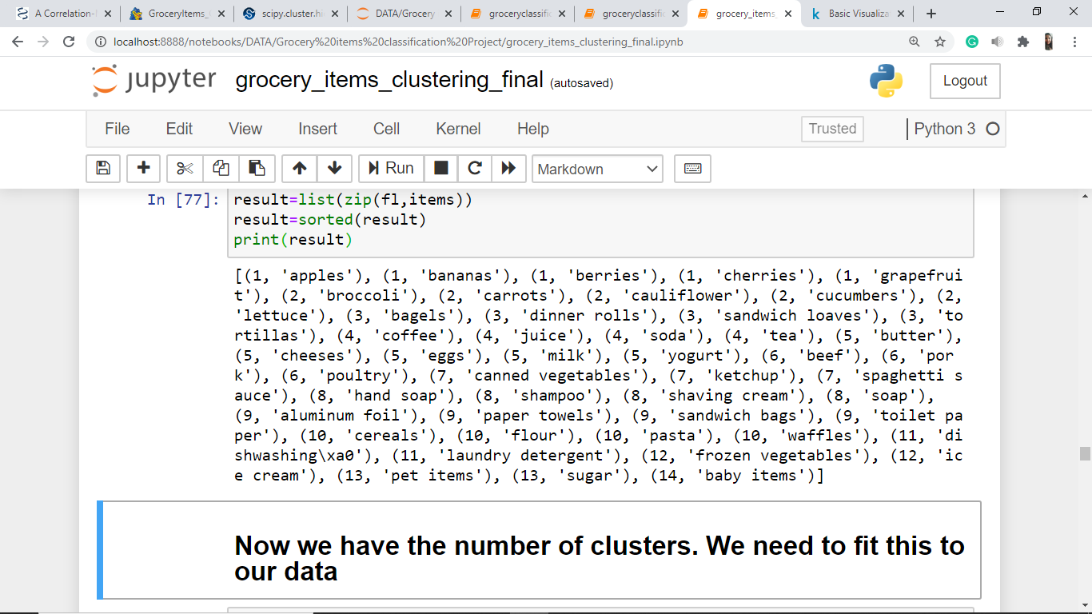

**Categories of items likely to be bought together:**

|  |  |
| --- | --- |
| Cluster 1 | Apples, Bananas, Berries, Cherries, Grapefruit |
| Cluster 2 | Broccoli, Carrots, Cauliflower, Cucumber, Lettuce |
| Cluster 3 | Bagels, Dinner Rolls, Sandwich Loaves, Tortillas |
| Cluster 4 | Coffee, Juice, Soda, Tea |
| Cluster 5 | Butter, Cheeses, Eggs, Milk, Yoghurt |
| Cluster 6 | Beef, Pork, Poultry |
| Cluster 7 | Canned Vegetables, Ketchup, Spaghetti Sauce |
| Cluster 8 | Hand Soap, Shampoo, Shaving Cream, Soap |
| Cluster 9 | Aluminum Foil, Paper Towels, Sandwich Bags, Toilet Paper |
| Cluster 10 | Cereals, Flour, Pasta, Waffles |
| Cluster 11 | Dishwashing, Laundry Detergent |
| Cluster 12 | Frozen Vegetables, Ice Cream |
| Cluster 13 | Pet items, Sugar |
| Cluster 14 | Baby items |

**Fitting the clusters to our data:**

We have found the optimal number of clusters, now we need to fit this to our data.

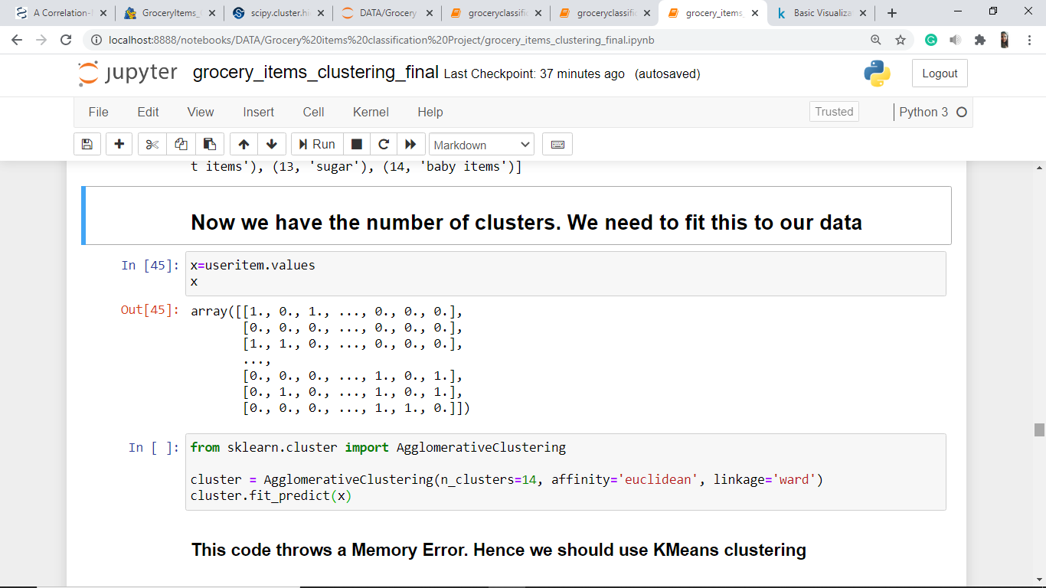

Using **Agglomerative Clustering** to fit the formed clusters to the data *x*:



The above code throws a **MemoryError**.

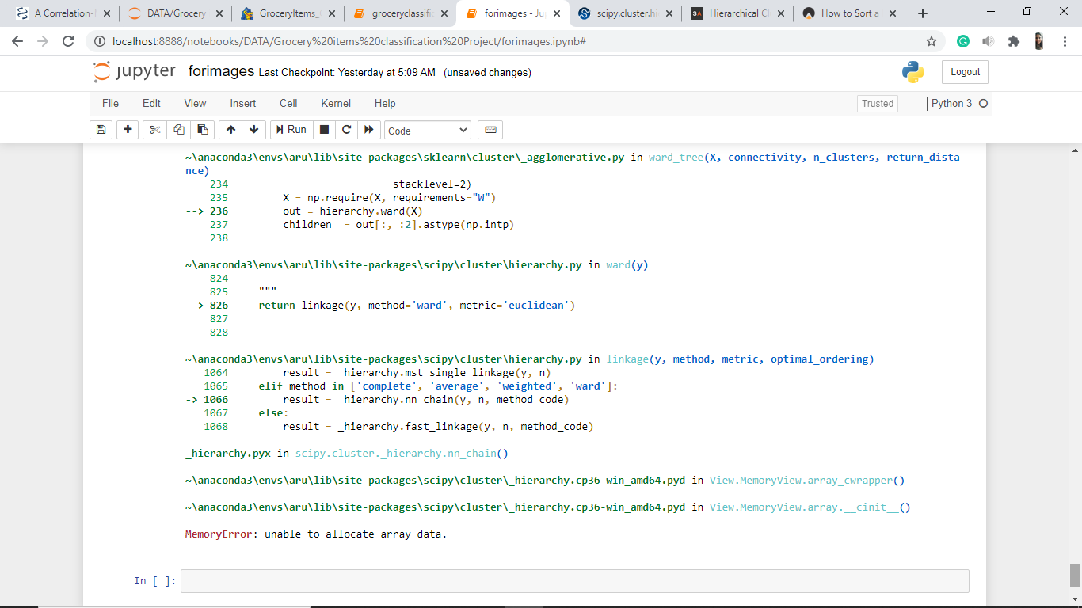

Fitting the clusters using any algorithm other than KMeans Clustering throws a Memory Error. Hence we need to use **KMeans Clustering** for this data.

**K Means Clustering:**

**Preparation of Data for KMeans Clustering:**

Principal component analysis (PCA). Linear dimensionality reduction using Singular Value Decomposition of the data to project it to a lower dimensional space.

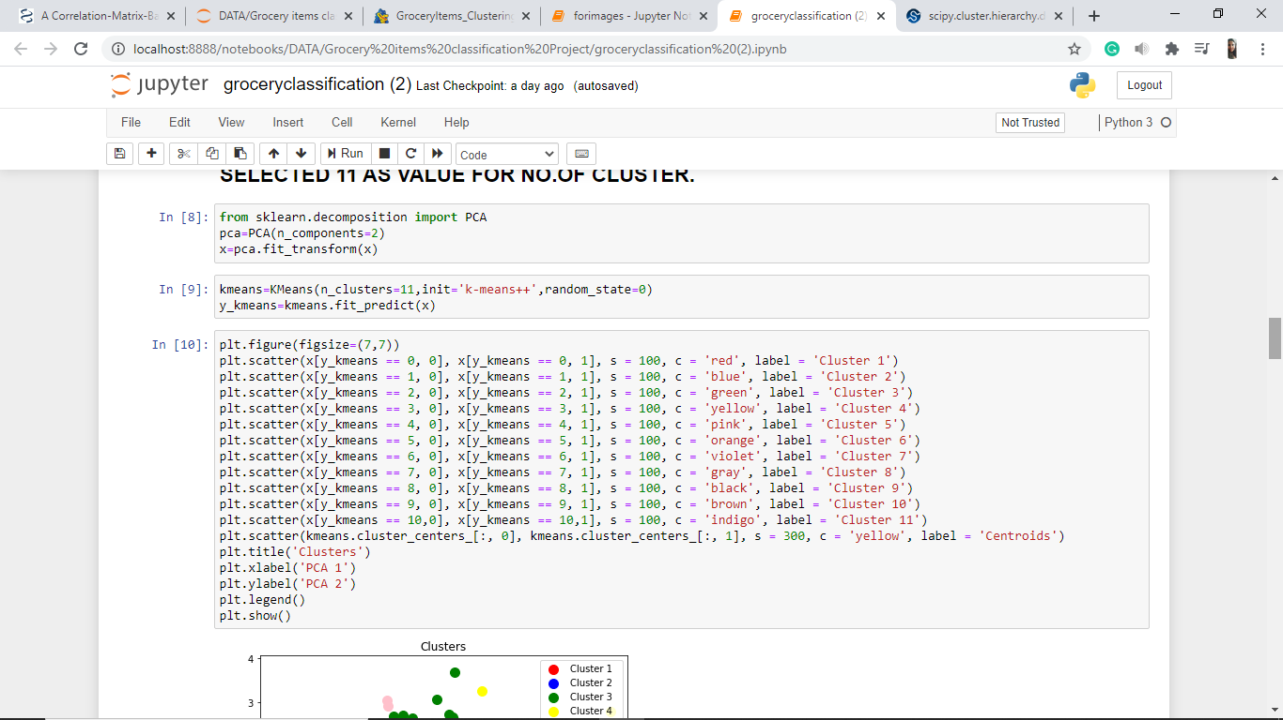

(KMeans imported previously for Elbow Method)

Number of clusters chosen = 14

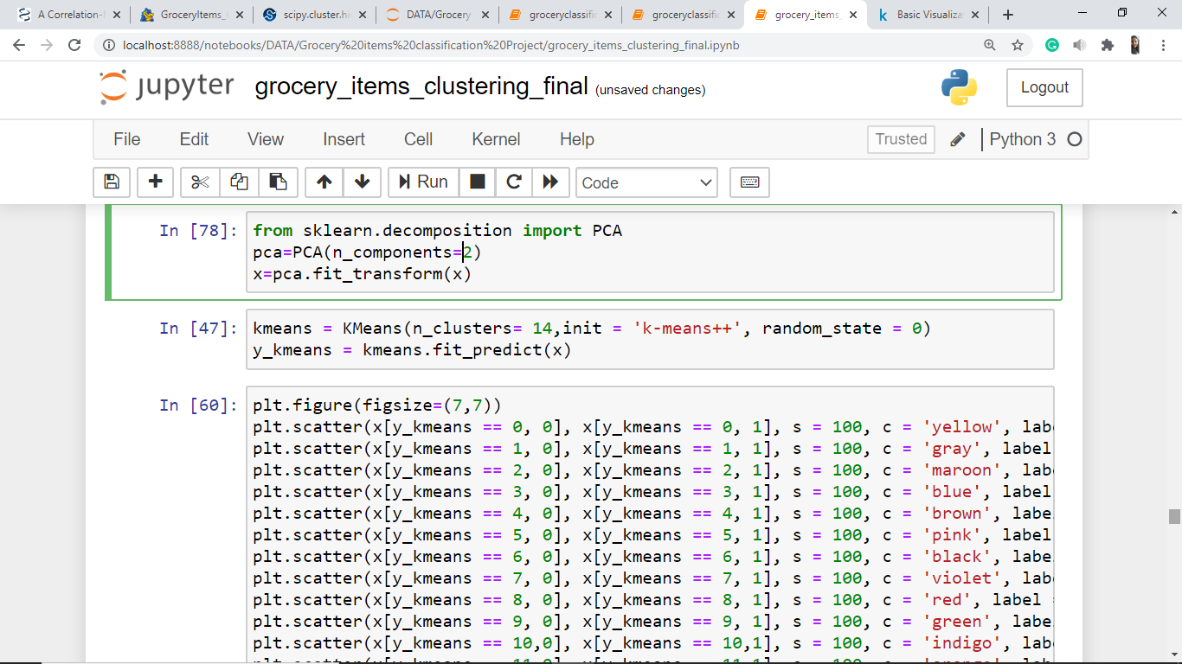

**Plotting the data with formed clusters:**

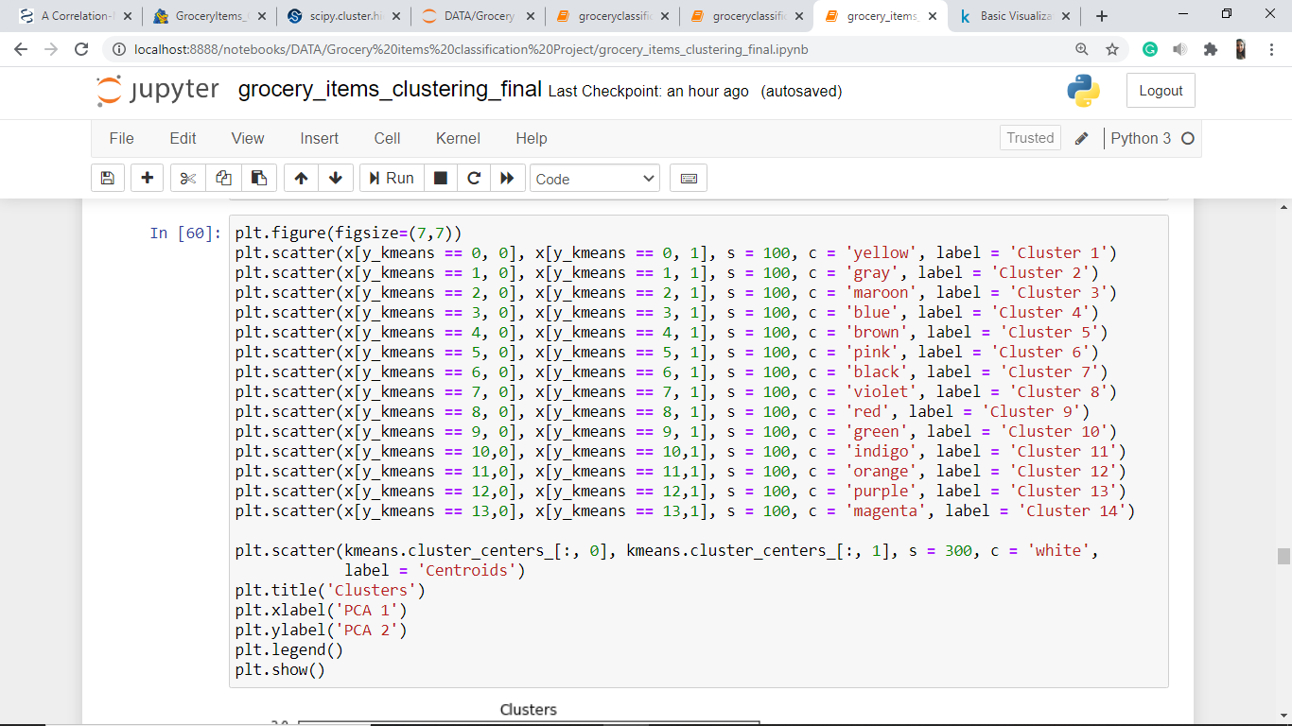

Scatter plot:

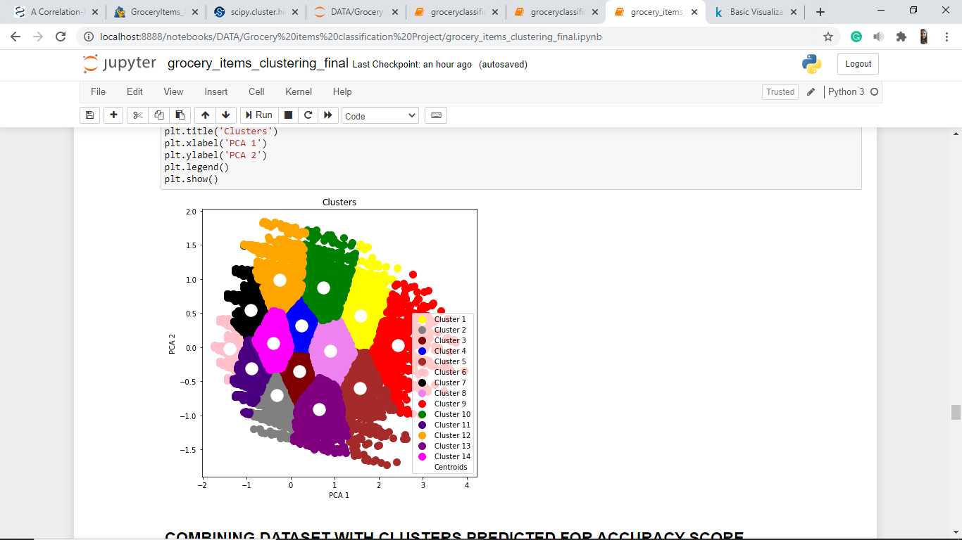

**DATA PREPARATION**

Now that we have formed the optimal number of clusters for our data, we need to combine the dataset with clusters predicted to get accuracy score of the classification.

Copying *useritem* DataFrame to *dataset*:

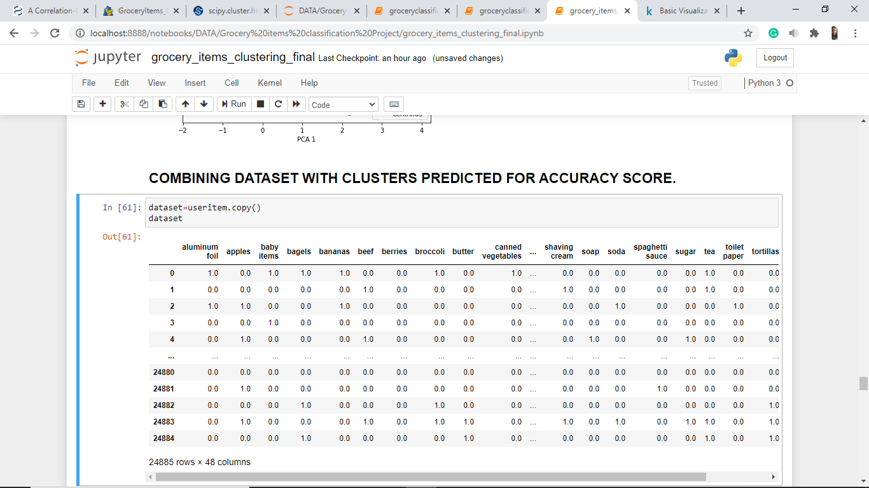

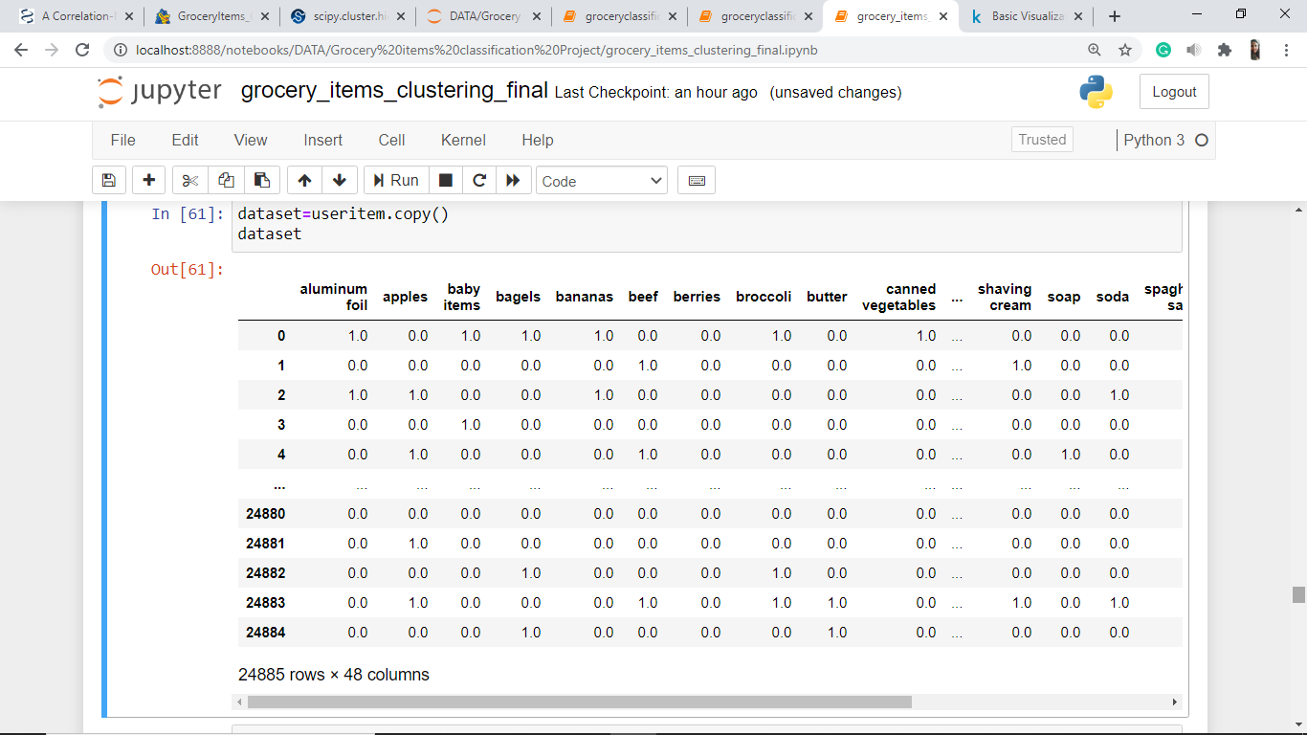

(Continued…)

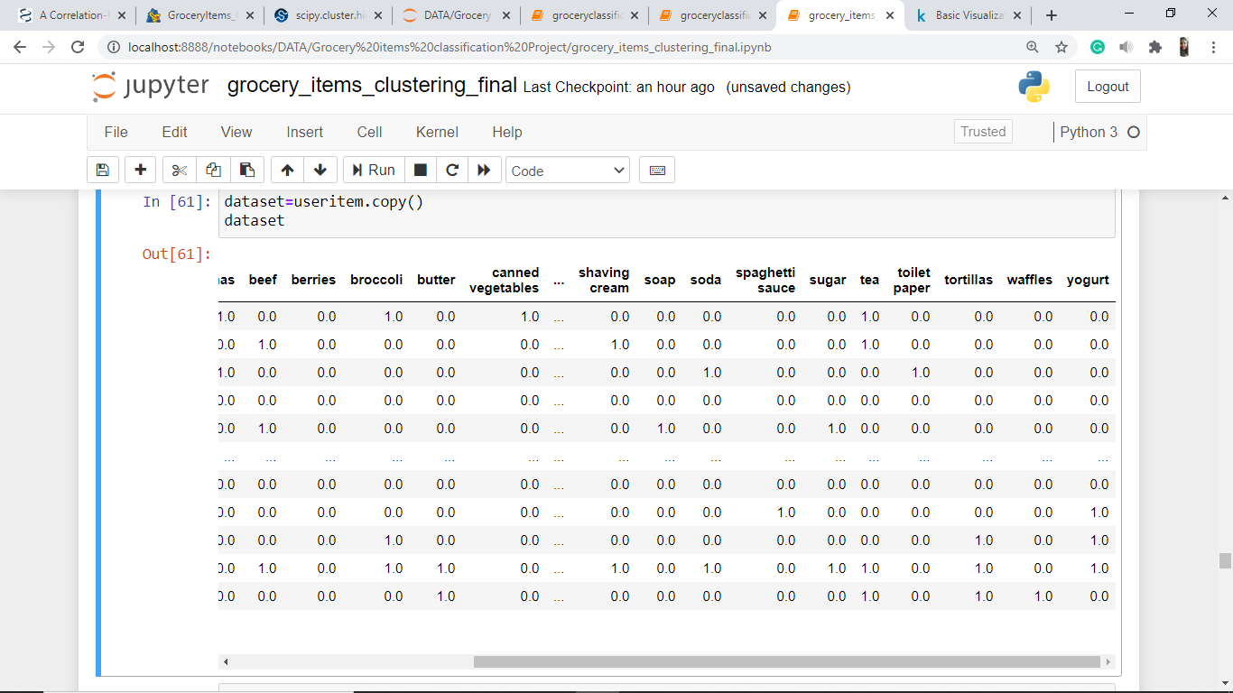

Reset the index of the DataFrame, and use the default one instead.

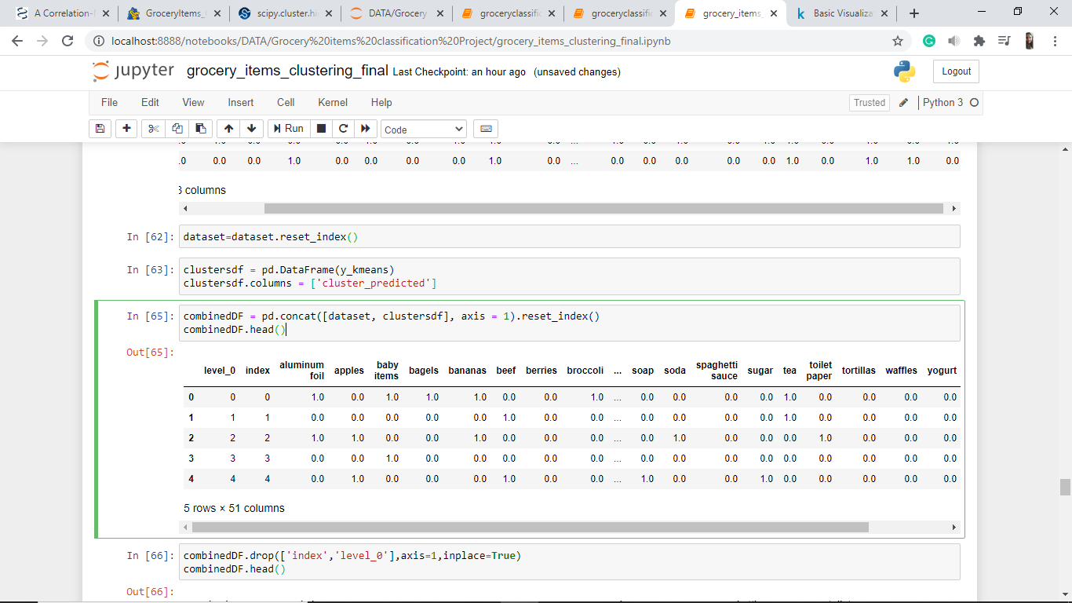

Creating DataFrame *clustersdf*

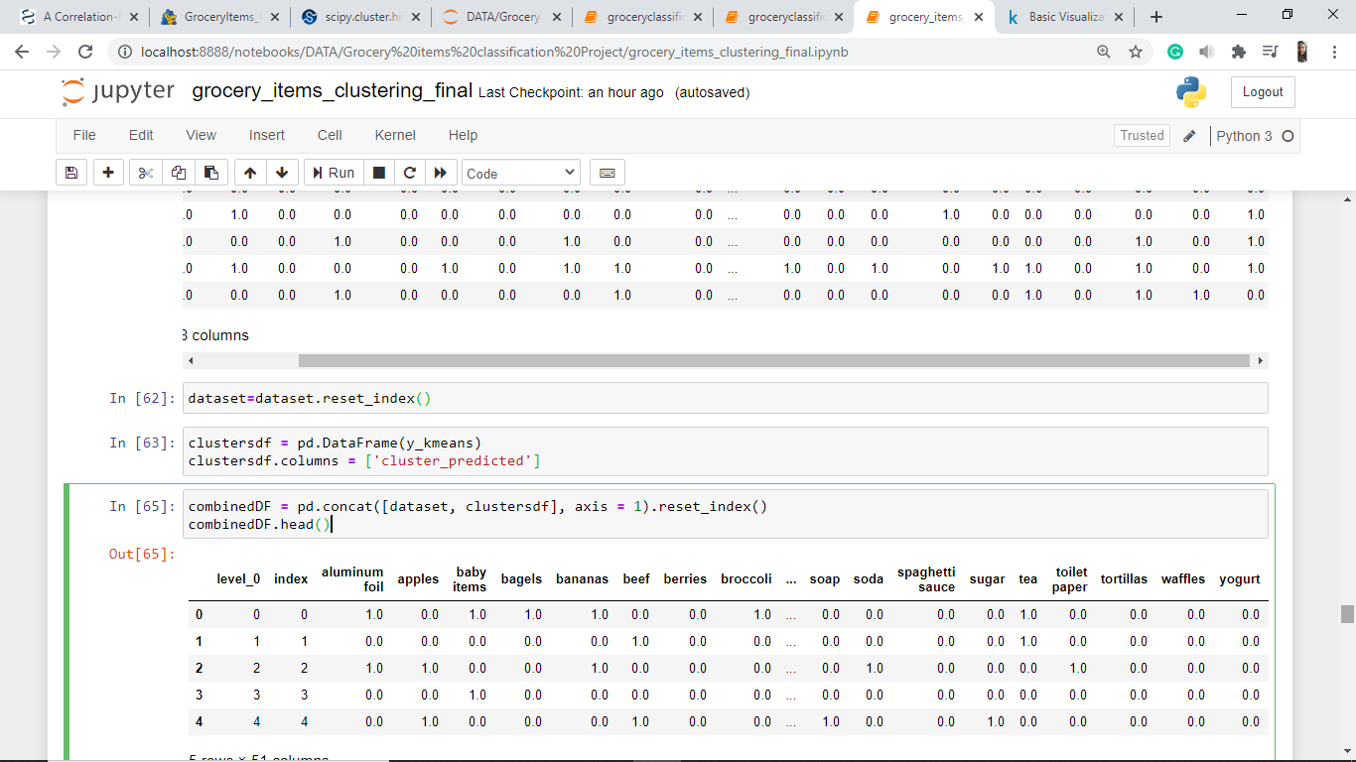

Creating *combinedDF* that contains *dataset* and *cluster_predicted* columns

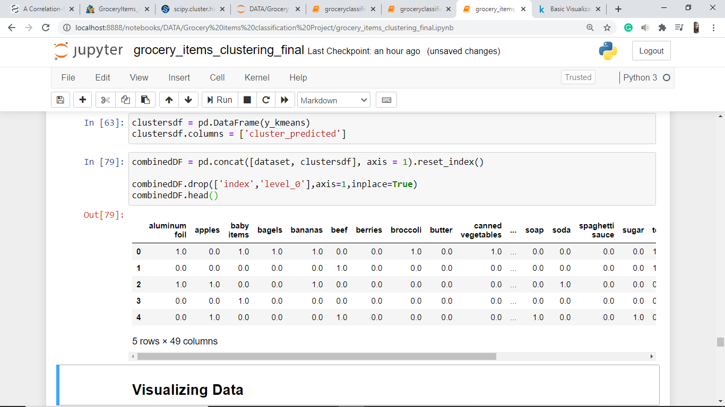



(Continued…)

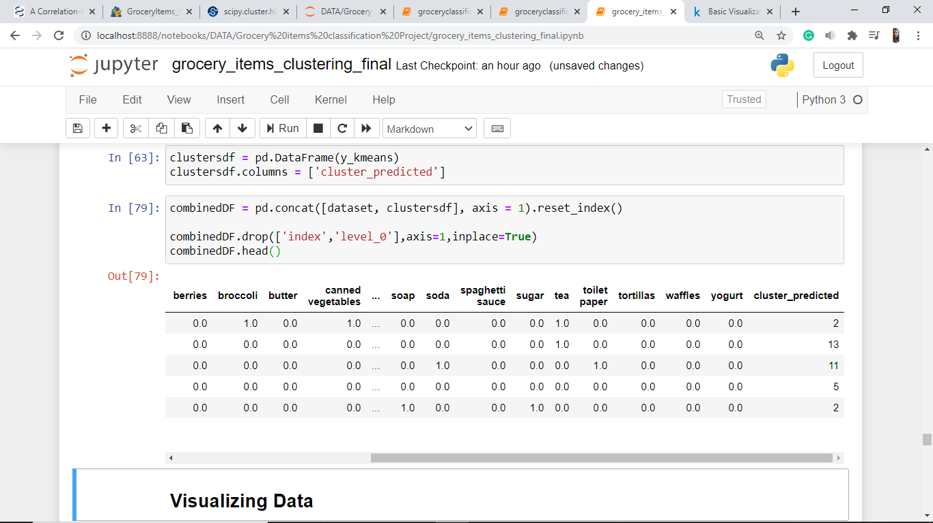

**DATA VISUALIZATION**

Plotting Histograms for all columns in *combinedDF* dataset:

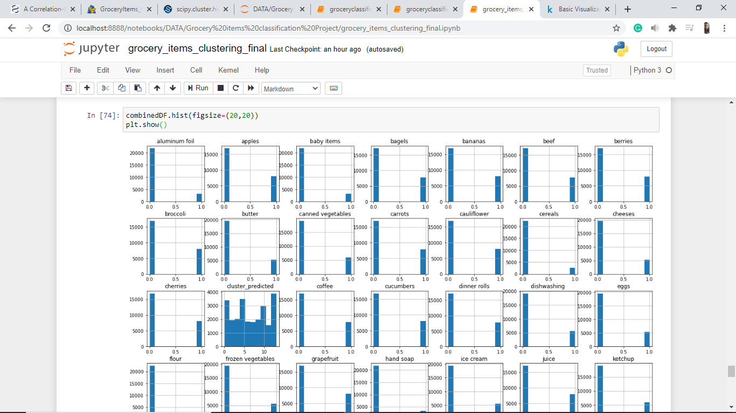

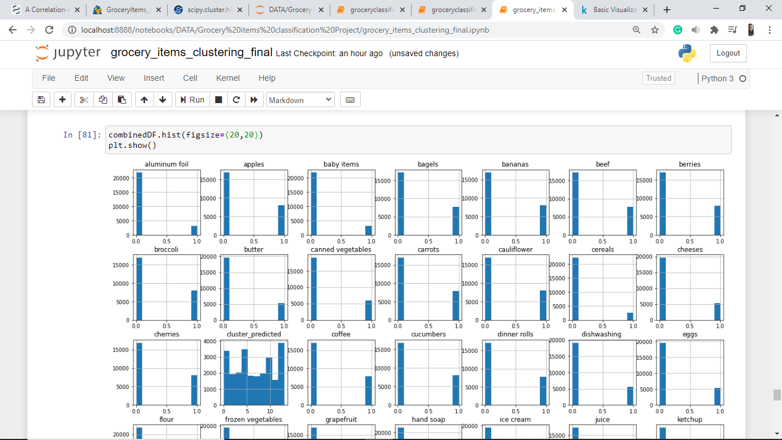

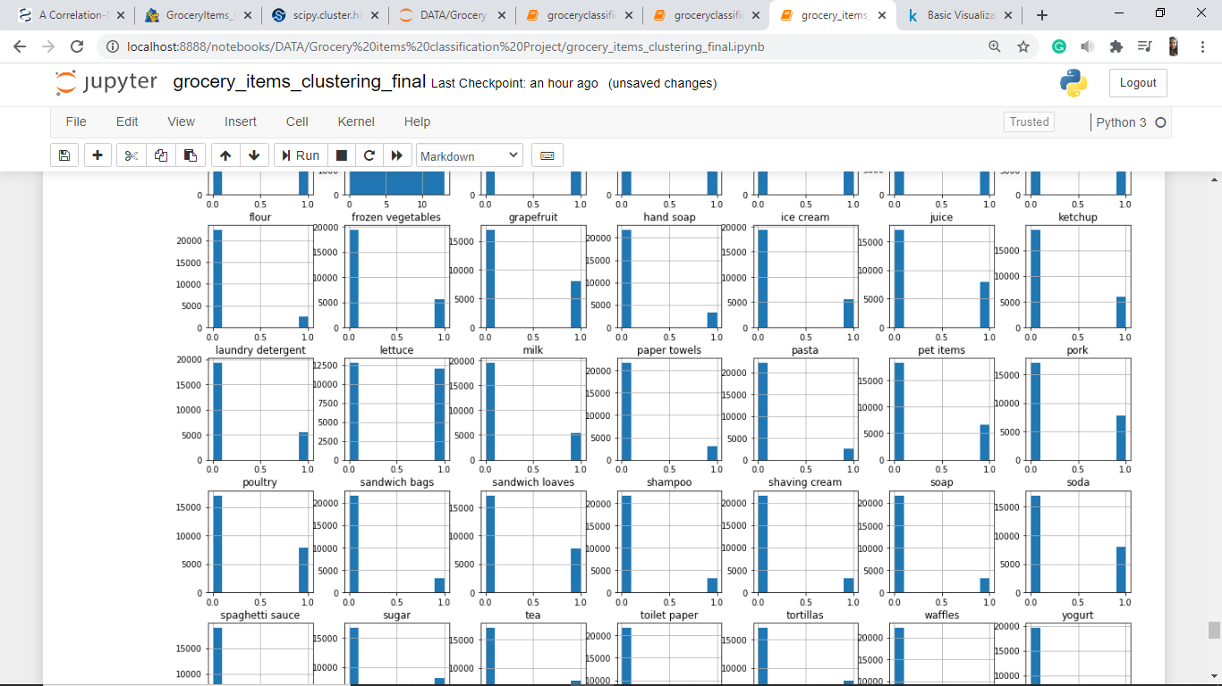

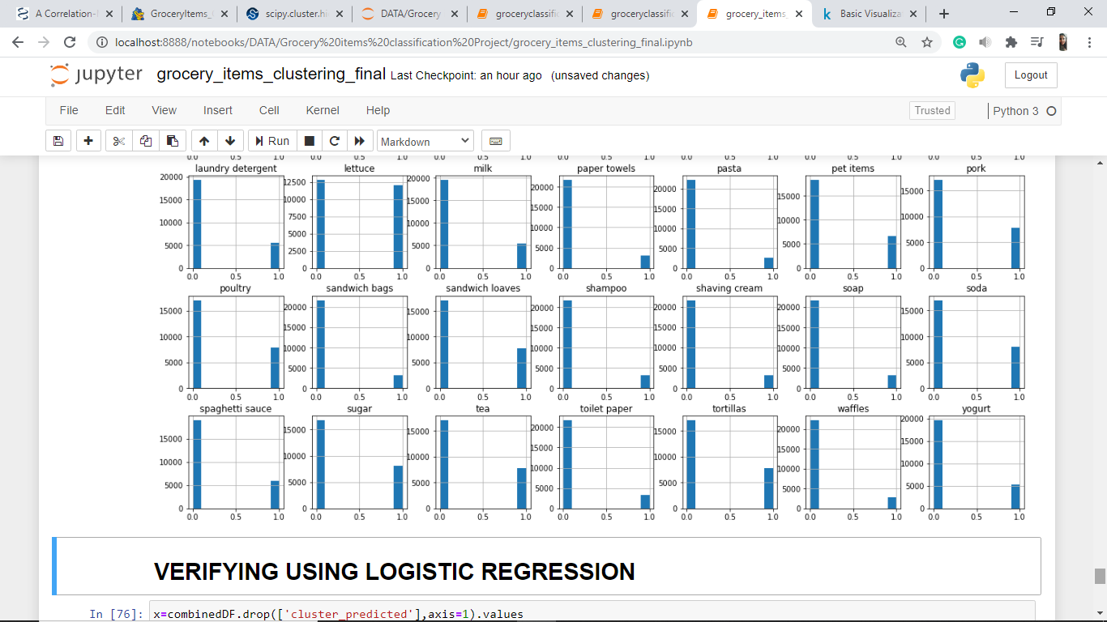

Plotting countplots for 3 columns, *aluminum foil*, *butter* and *waffles*:

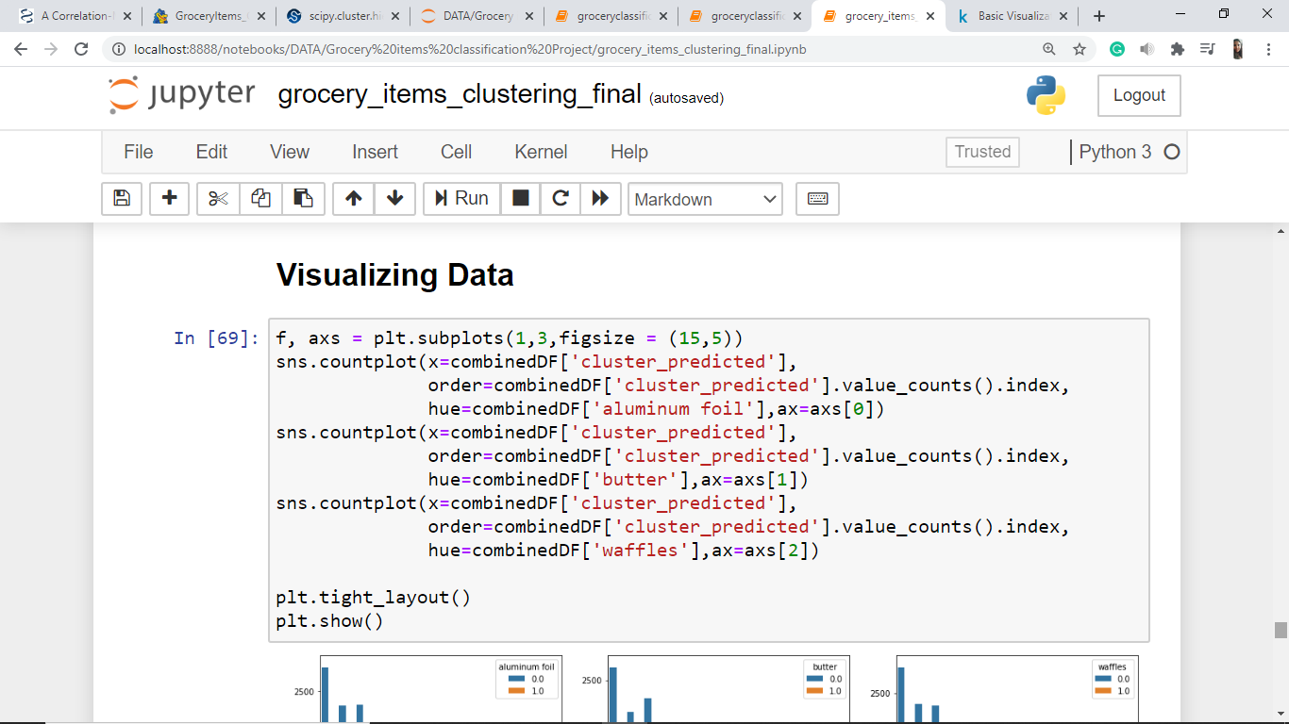

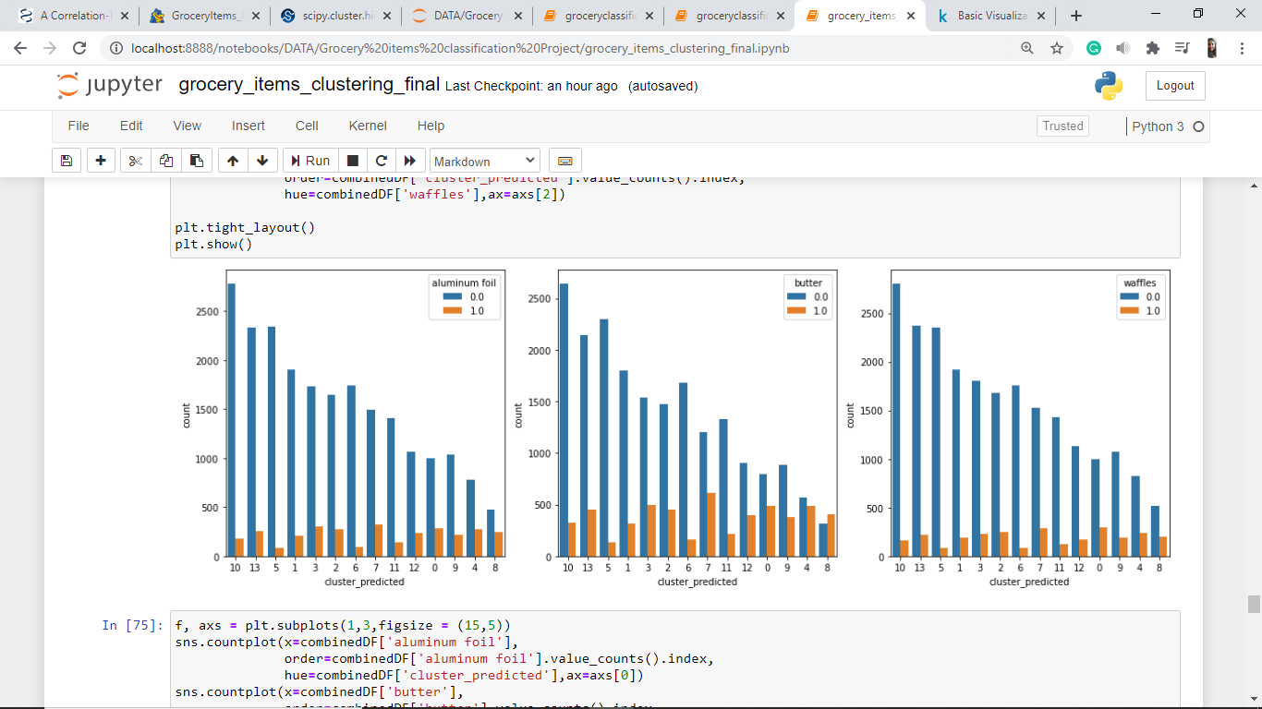

Plotting barplot for *cluster_predicted*:

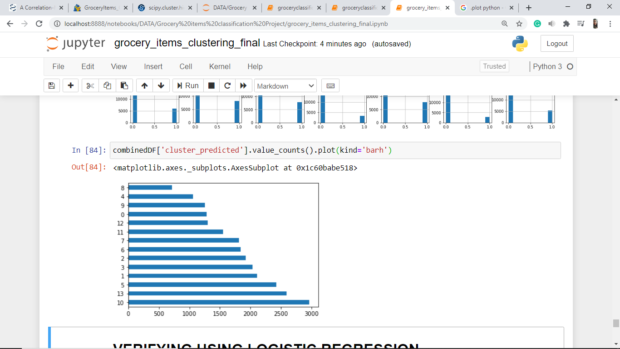



Plotting Pie Chart for *cluster_predicted*:

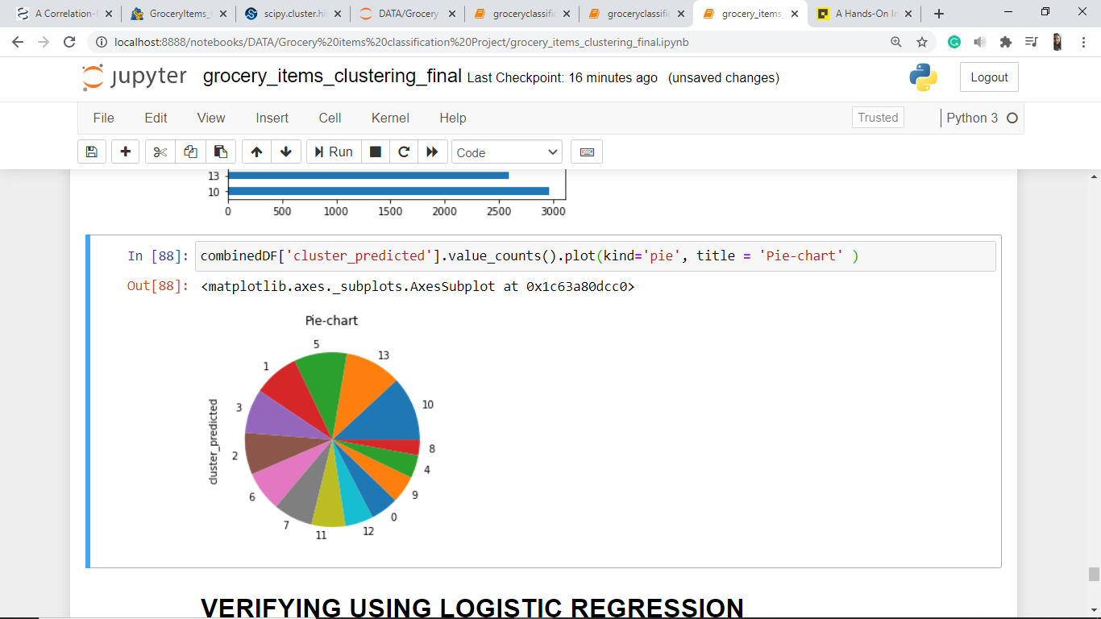



**VERIFICATION USING CLASSIFICATION**

We have created clusters using KMeans clustering and given a label to our dataset rows representing the cluster that row belongs to. Now we need to check the accuracy of these formed clusters using classification algorithm.

Here we pick the **Logistic Regression** algorithm.

**Logistic Regression:**

Logistic regression is a classification algorithm used to assign observations to a discrete set of classes. Logistic regression transforms its output using the logistic sigmoid function to return a probability value.

**Preparation of Data for Logistic Regression:**

**Splitting dataset into features and label**

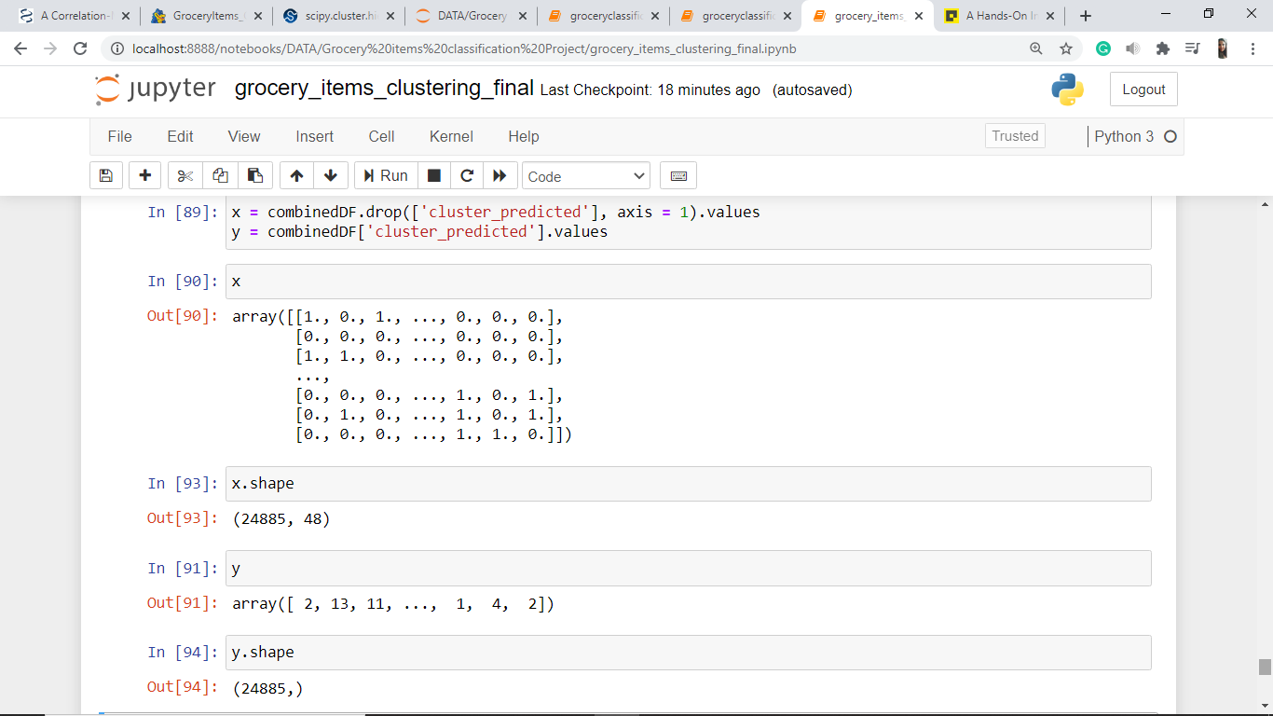





**Splitting dataset into train and test sets:**

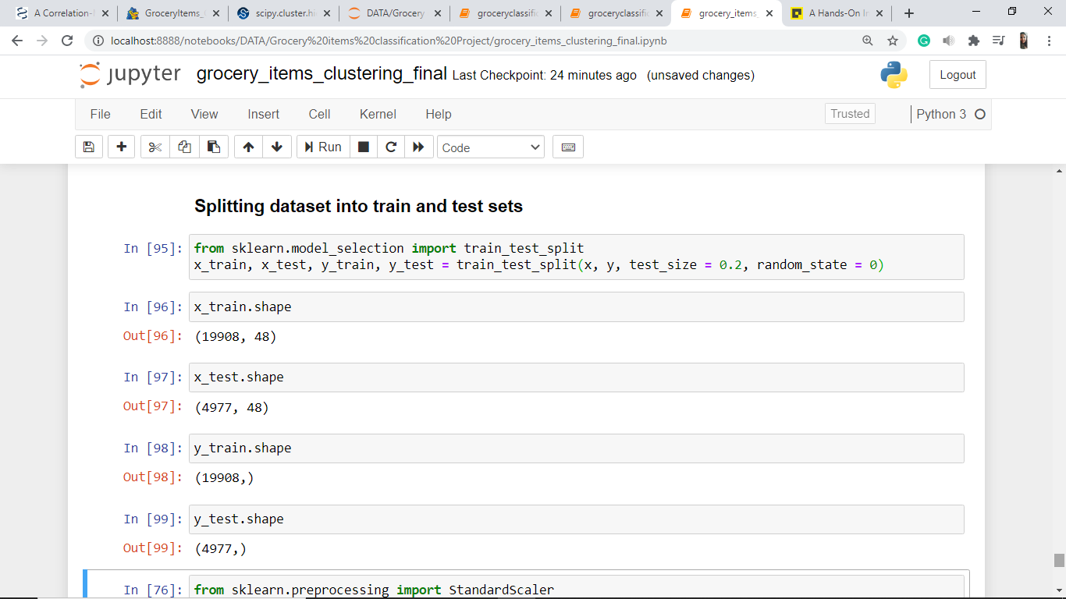



**Scaling the data:**

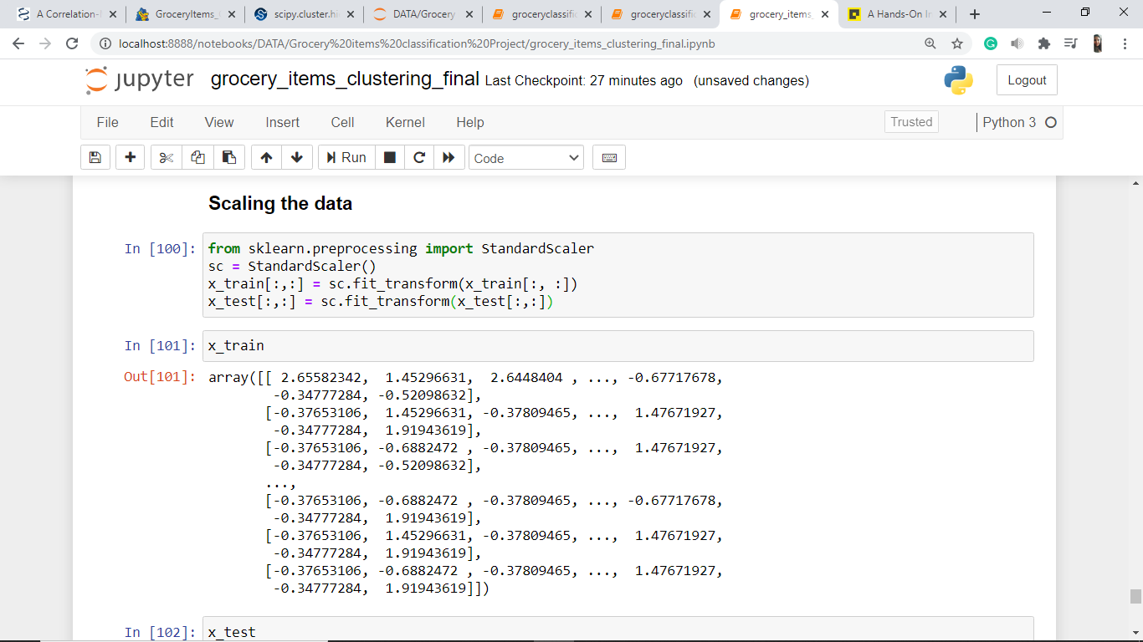



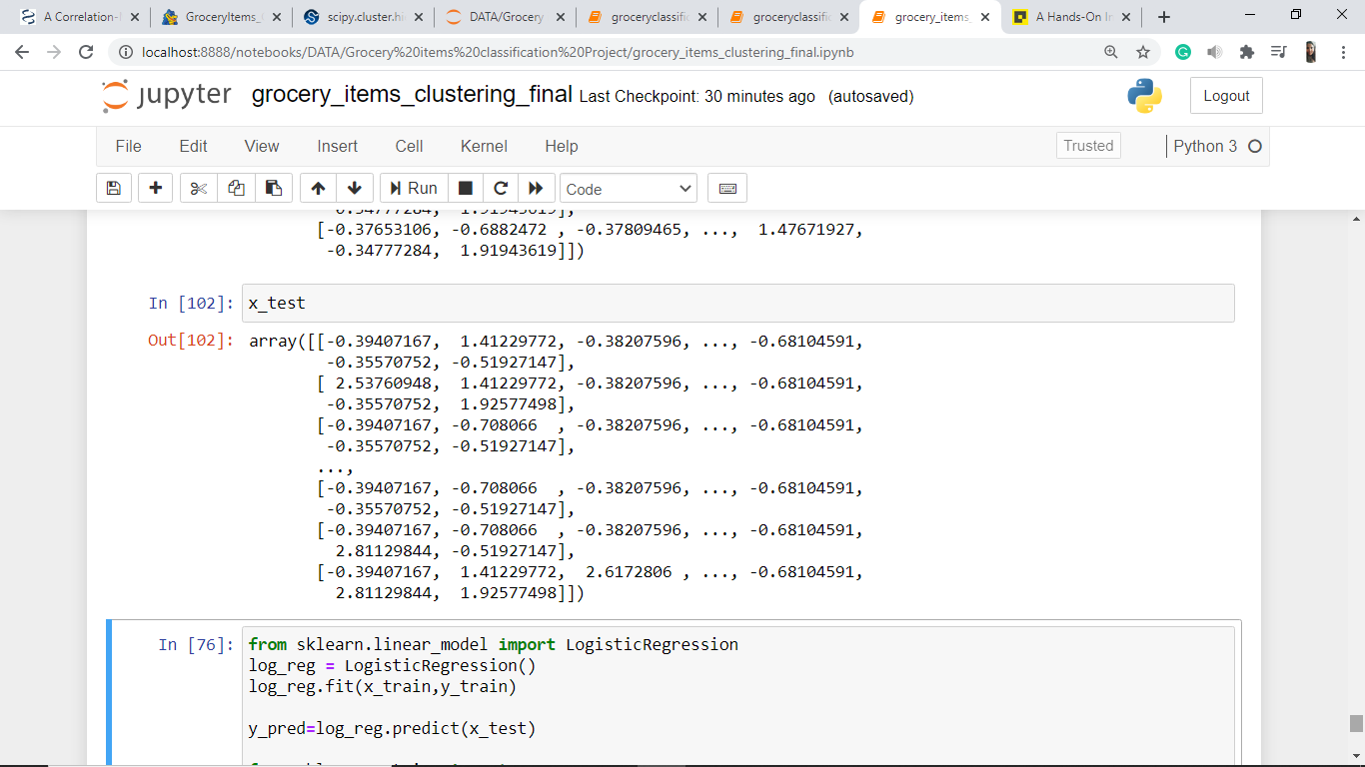

**Importing *LogisticRegression* library from *sklearn*:**

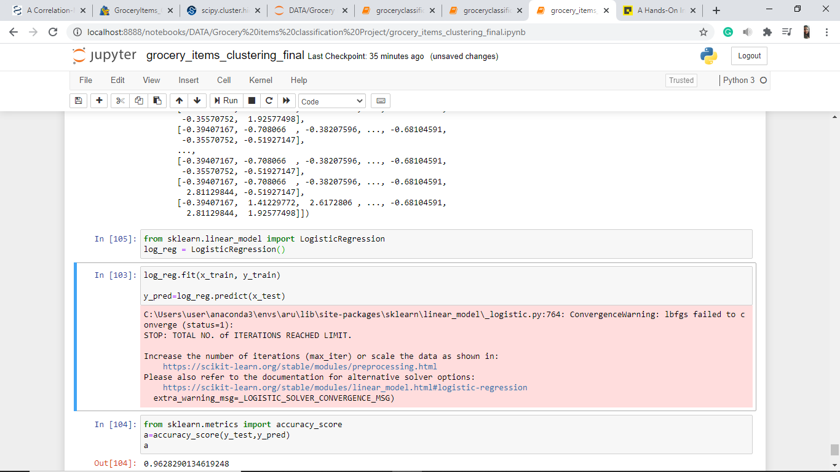

**Fitting the model to our data**

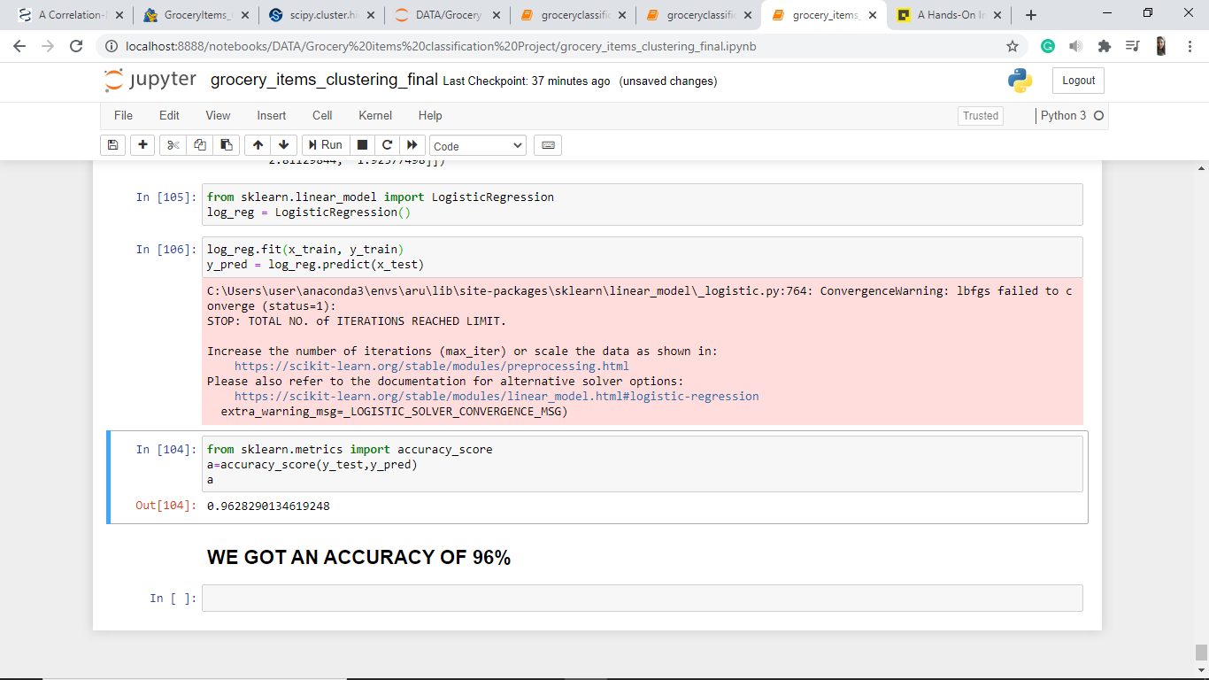

**Checking Accuracy of our model using *accuracy_score*:**



**We got accuracy of 96.28%.**

**CONCLUSION**

**Result of problem statement 1:**

The user with user_id = 269335 has bought 72 items in their lifetime.

**Result of problem statement 2:**

The *df* dataframe below contains the item name and the customer id of the customer who has bought that item the most.





**Result of problem statement 3:**

There exist 14 clusters for the given grocery items that are likely to be bought together. They are:

|  |  |
| --- | --- |
| Cluster 1 | Apples, Bananas, Berries, Cherries, Grapefruit |
| Cluster 2 | Broccoli, Carrots, Cauliflower, Cucumber, Lettuce |
| Cluster 3 | Bagels, Dinner Rolls, Sandwich Loaves, Tortillas |
| Cluster 4 | Coffee, Juice, Soda, Tea |
| Cluster 5 | Butter, Cheeses, Eggs, Milk, Yoghurt |
| Cluster 6 | Beef, Pork, Poultry |
| Cluster 7 | Canned Vegetables, Ketchup, Spaghetti Sauce |
| Cluster 8 | Hand Soap, Shampoo, Shaving Cream, Soap |
| Cluster 9 | Aluminum Foil, Paper Towels, Sandwich Bags, Toilet Paper |
| Cluster 10 | Cereals, Flour, Pasta, Waffles |
| Cluster 11 | Dishwashing, Laundry Detergent |
| Cluster 12 | Frozen Vegetables, Ice Cream |
| Cluster 13 | Pet items, Sugar |
| Cluster 14 | Baby items |

The clusters were formed by plotting a Dendrogram using Hierarchical Clustering.

The clusters were fit to the data using KMeans Clustering.

When the accuracy of the formed clusters was tested using Logistic Regression Classification, we got an accuracy of 96.28%.

**REFERENCES**

Links:

<https://scikit-learn.org/stable/modules/clustering.html>

<https://www.ncbi.nlm.nih.gov/pmc/articles/PMC3477851/>

<https://docs.scipy.org/doc/scipy/reference/generated/scipy.cluster.hierarchy.dendrogram.html#:~:text=Plot%20the%20hierarchical%20clustering%20as,singleton%20cluster%20and%20its%20children.&text=It%20is%20also%20the%20cophenetic,in%20the%20two%20children%20clusters.>

<https://matplotlib.org/3.3.0/api/_as_gen/matplotlib.pyplot.scatter.html>

<https://pandas.pydata.org/pandas-docs/stable/reference/api/pandas.DataFrame.plot.barh.html>

<https://scikit-learn.org/stable/modules/generated/sklearn.decomposition.PCA.html>

<https://scikit-learn.org/stable/modules/generated/sklearn.linear_model.LogisticRegression.html>